PROPOSAL

AHP APPROACH TO DETERMINE KEY CRITERIA

IN CREATING TV TEMPO YOUTUBE CONTENT

TO IMPROVE ORGANIZATIONAL PERFORMANCE


RESEARCH

RR. ARIYANI YAKTI WIDYASTUTI (2502446495)

A Thesis Submitted to the Graduate Faculty
In Partial Fulfilment of the Requirements
for Master of Management Degree
Major: Strategic Management
PROPOSAL

AHP APPROACH TO DETERMINE KEY CRITERIA

IN CREATING TV TEMPO YOUTUBE CONTENT

TO IMPROVE ORGANIZATIONAL PERFORMANCE

RESEARCH

RR. ARIYANI YAKTI WIDYASTUTI (2502446495)

Supervisor:

Dr. Ir. Dewi Tamara, MM., MS., CERA, CBV
21 February 2025
PROPOSAL

AHP APPROACH TO DETERMINE KEY CRITERIA

IN CREATING TV TEMPO YOUTUBE CONTENT

TO IMPROVE ORGANIZATIONAL PERFORMANCE

RESEARCH

RR. ARIYANI YAKTI WIDYASTUTI (2502446495)

BINUS BUSINESS SCHOOL
MASTER OF MANAGEMENT IN STRATEGIC MANAGEMENT
BINUS UNIVERSITY
JAKARTA
2025
STATEMENT PAGE

I, Rr, Ariyani Yakti Widyastuti, 2502446495, truly acknowledge that my thesis with title “AHP Approach to Determine Key Criteria in Creating TV TEMPO YouTube Content to Improve Organizational Performance” is my concept and the project result with the guidance from supervisor.
I, also truly acknowledge that contents of this thesis are not copied and not from another people work, except my citation from literature or written interview result and already written in reference list.
That’s my acknowledgement truly made and if in reality this wasn’t true, I am willing to be sanctioned.
Note: in case of slight differentiation between the English and Indonesian version, refer to the Indonesian version instead.

Jakarta, 21 February 2025,
Stated by

RR. ARIYANI YAKTI WIDYASTUTI
2502446495
STATEMENT

I, With this, I,

Name : Rr. Ariyani Yakti Widyastuti
NIM : 2502446495
Thesis Title : “AHP Approach to Determine Key Criteria in Creating TV TEMPO YouTube Content to Improve Organizational Performance”
Hereby grant to my school, Bina Nusantara University, the non-exclusive right to archive, reproduce, and distribute my thesis, in whole or in part, whether in the form of printed and electronic formats.
I acknowledge that I retain exclusive rights of my thesis by using all or part of it in the future work or outputs, such as article, book, software, and information system.
Note: in case of slight differentiation between the English and Indonesian version, refer to the Indonesian version instead.

Jakarta, 21 February 2025

RR ARIYANI YAKTI WIDYASTUTI

PREFACE

Gratitude goes to Almighty God who has given His blessing so the author can finish the research with title “AHP Approach to Determine Key Criteria in Creating TV TEMPO YouTube Content to Improve Organizational Performance” on the right time.
The author also delivers her thanks to people who has guided and helped her during the thesis writing:
- Dr. Nelly, S. Kom., M.M., CSCA as Rector of Binus University
- Prof. Dezie Leonarda Warganegara, Ph.D as Dean of Binus Business School Master Program
- Dr. Ir. Dewi Tamara, MM., MS., CERA, CBV, as Head of MM International Program and the supervisor who has supportively advised and guided the author to finish this thesis.
4) The author’s parents and family who has been supportive during her study.
5) Classmates and teammates of MMEXE 2023/2025 and Binus Business School
This thesis was submitted to fulfil the master of management degree in Binus Business School. Through this thesis, the author wishes to contribute in the theoretical and practical area, specifically related to program development of YouTube TV TEMPO.
The author is aware that this thesis is still far from perfect which also encourages more researcher to deep dive and develop the same topic for new findings.

Jakarta, February 2025

Rr. Ariyani Yakti Widyastuti
ABSTRACT

Technological disruption should not be always considered as a threat but an inevitability. The media industry must also be able to adapt quickly and be agile to take advantage of its own potential niches in order to survive in the increasingly challenging business competition, including TEMPO.
TEMPO, a 53-year-old media company, is very aware that it can no longer rely solely on advertising revenue and slowly started switching to a subscription-based business model. That way, the company will be more independent in its main duty as a clearing house of information.
In turnaround business strategy, TEMPO is also nurturing its subsidiary company, PT Dimensi Idea Kreatif (TV TEMPO) by optimizing YouTube as a new machine of revenue, primarily through programs that successfully attract new and larger scope of subscribers who are digital-savvy.
To do that, a tool is needed to be a guideline on priority ranking of criteria and programs that will be prioritized for next development and strategic steps must be taken in encouraging TEMPO YouTube content to remain quality and achieve the company's main targets. Especially the amount of business competitor is continuously getting bigger and not only comes from media company.
Departing from that need, this research will use the Analytical Hierarchy Process (AHP) tool which has been widely recognized method for addressing multi-criteria decision-making challenges. This research becomes more strategic because up until now the research focused on determination of the criteria in YouTube content creation to improve organizational performance is still rare, primarily mentioning TV TEMPO.
There will be twenty one experts involved to fill out the criteria and program ranking questionnaire in this research. They are journalist from digital media, youtuber or content creator, digital marketing experts, academist from public communication background, socio-political practitioner, SEO specialists and TV TEMPO YouTube specialists.
After going through a series of analysis, synthesis steps, and interview with the related stakeholders, it is hoped that output of this study will be useful not only for TEMPO internally but also for the wider community.

Keyword: AHP, criteria, decision making, media, ranking, sub criteria, technology disruption TEMPO
TABLE OF CONTENT

COVER 1
TITLE PAGE 1
SUPERVISOR APPROVAL PAGE 2
STATEMENT PAGE 4
STATEMENT 5
PREFACE 6
ABSTRACT 7
TABLE OF CONTENTS 8
LIST OF TABLES 10
LIST OF FIGURES 11
CHAPTER I
INTRODUCTION 12
1.1 Research Background 12
1.2 Research Problem 20
1.3 Research Question 21
1.4 Research Objectives 21
1.5 Research Contributions 21
1.6 Research Scope 22
1.7 Structure of the Thesis 23

CHAPTER II
LITERATURE REVIEW 24
2.1 Dynamic of Media Industry 24
2.1.1 Digital Transformation in Media Company 24
2.1.2 Shifting to Subscription-Based Model 25
2.2 New Opportunity via YouTube 26
2.3 Overview of Analytical Hierarchy Process (AHP) 27
2.3.1 The Advantage of AHP 29
2.3.2 Previous Studies 30
2.4 Criteria, Sub-Criteria and Alternative
2.4.1 Criteria and Sub-Criteria
2.4.2 Alternative

CHAPTER III
RESEARCH METHODOLOGY 33
3.1 Research Framework 33
3.2 Criteria and Sub-criteria 34
3.3 Collection Data Process 35
3.3.1 Primary Data 35
3.3.2 Secondary Data 35
3.4 AHP Model 37
3.4.1 Steps in AHP 37
3.4.2 Questionnaire 40

CHAPTER IV
DATA ANALYSIS AND DISCUSSION
4.1 Data Analysis
4.1.1 Profile of Respondent
4.1.1.1 Stratified Simple Random Sampling
4.1.1.2 Composition of Respondent
4.1.1.3 Respondent Profile
4.1.2 Profile of TEMPO YouTube Program
4.1.2.1 Talk Show
4.1.2.2. Video
4.1.2.3 Editorial
4.1.2.4 Explanatory
4.1.3 Criteria Analysis
4.1.4 Alternative Analysis
4.1.5 Interview with Related Stakeholder
4.2 Discussion

REFERENCE LIST 41
APPENDIX 43
- Respondent Profile
- Questionnaire

BIOGRAPHY 49

LIST OF TABLES

Table 1.1 Top Social, Messaging and Video Networks in Indonesia 17
Table 1.2 Performance per Product of TEMPO in 2020-2023 18
Table 1.3 Performance of News-Based Playlist Title of TV Tempo YouTube in 2024 18
Table 1.4 Monthly Performance of TV TEMPO YouTube in 2024 19
Table 2.1 AHP Pairwise Comparison Table 30
Table 2.2 Summary of Literatures Comparing Usage of AHP 30
Table 3.1 Criteria and Sub-criteria on YouTube Content Analysis 34
Table 3.2 Rating from Experts 35
Table 3.3 Matrix Preference Comparison A (nxn) 39
Table 3.4 Saaty’s Random Consistency Index (RI) 39
Table 3.5 Illustration of Questionnaire Form 40

LIST OF FIGURES

Figure 1.1 Mobile Internet Penetration Rate in Indonesia 2018-2029 12
Figure 1.2 Leading Countries Based in YouTube Audience Size per July 2024 (in Millions) 13
Figure 1.3 Media Reach Offline per Week in Indonesia (TV, Radio, Print) 15
Figure 1.4 Media Reach Online per Week in Indonesia 15
Figure 1.5 Source of News in Indonesia 2021-2024 16
Figure 2.1 The Structure of AHP Method 28
Figure 3.1 Research Framework 33
Figure 3.2 Hierarchical Diagrams in Determining Key Criteria in TEMPO TV
YouTube Content Creation 37
Figure 3.3 Flowchart for Problem Solving using AHP Model 38

CHAPTER 1

INTRODUCTION

1.1 Research Background
Indonesia is known as a fast a growing number Internet user in the world. Data released by Association of Indonesian Internet Service Providers (APJII) showed that in 2024, Internet user in this country reached out 221,5 million inhabitants or 79,5 percent of total 279 million Indonesia’s population (Antara, 2024). That indicates significant growth of massive Internet penetration in Indonesia if compared to data in January 2017 that 51 percent of 258 million population use Internet.
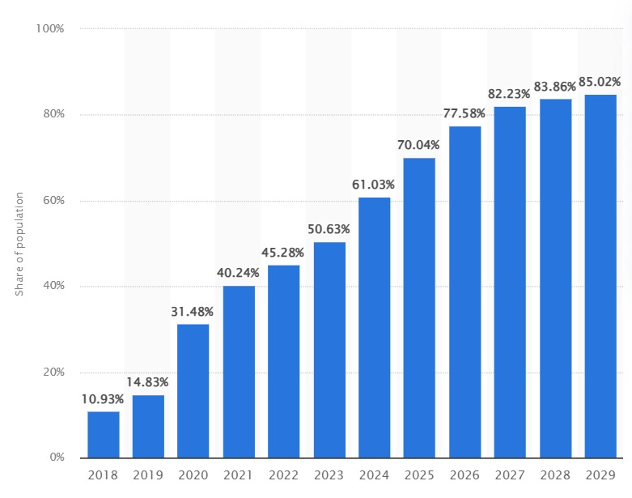
Statista data also shows the growth of mobile internet penetration in Indonesia from 2018 at 10,93% to 61,03% last year. Figure 1.1 below shows the projected number of mobile internet penetration in Indonesia will go up to 85,02% in 2029.

Figure 1.1 Mobile Internet Penetration Rate in Indonesia 2018-2029
Source: Statista (2025)

The mobile Internet penetration rate in Indonesia increase exponentially per year. Big number of this Internet usage pushed media companies to change the business form into online news in the last decades. They set up websites and later create apps to get their products can be reached more easily by the gadget users and grab their traditional newsreaders back.
Data of Indonesia Press Council shows that there is 1.711 verified media company in Indonesia per January 2023, and 902 companies of them are digital media ones. The rest are 423 printing media companies, 369 television stations and 17 radio stations.
Big number of digital media companies also contribute massive quantity of news which virally being disseminated through social media. With most of the Internet user in Indonesia access various social medias, such as Facebook, Twitter, YouTube, etc, Statista specifically showed that in Figure 1.2., Indonesia was on the fourth biggest YouTube users in the world and according to We Are Social report in the same time period. Per July 2024, there are 139 million YouTube users in Indonesia.
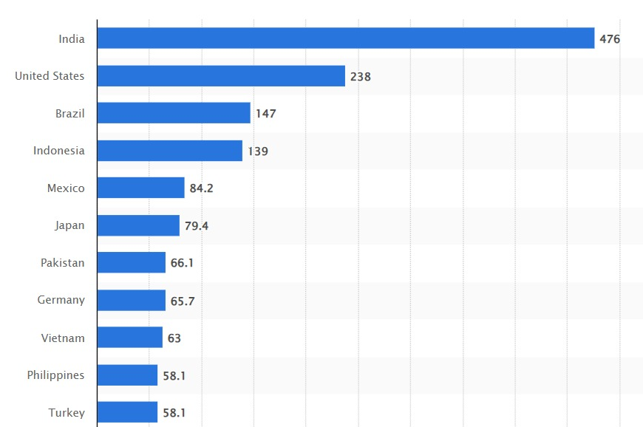

Figure 1.2 Leading Countries Based in YouTube Audience Size per July 2024 (in Millions)
Source: Statista (2024)

Meanwhile, according to latest data from Reuters Institute News Digital Report 2024, trend of global news consumption from media social decreased over the past view years. As a replacement, video platform as a main source of online news becomes more important, primarily among the young generation.
For example, the survey held on 17 June 2024 showed news in short video format were accessed by 66 percents of respondents, but the news in longer video format attracted 51 percents of total respondent. The main focus of news consumption in video format is from online platform (72 percents), higher than the ones produced by news media company (22 percents).
That trend reflected the impact of social media like Facebook and X which actively reduced dominance and news contribution in each platform. That was aligned with their policy in adding investment on content creator with format and video network as their competitive advantage.
While news consumption via Facebook reached 37 percents or decreased 4 percents compared to last year globally, the rest came from: YouTube as the source of weekly news by 31 percents of respondents, followed by WhatsApp (21 percent), TikTok (13 percent) and X (10 percent).
Head of Research Team Reuters Institute Digital News Report 2024, Nic Newman, said the video succeeded in attracting more audiences because the platform are easy to access and provide more options and engagement contents. While the traditional newsroom (Wuragil, 2024) still struggled in text-based culture try to catch up and adapt the articles to be more welcomed by readers.
The next Figure 1.3 and Figure 1.4 below from Reuters Institute Digital News Report in 2024 shows TEMPO’s position on media reach offline and online per week compared to peer offline media (TV, radio and print) and online media.
From the comparison of media reach offline, we can see TEMPO is on the 13th ranking as the choice of Indonesian readers. The survey shows that 12% of all the Indonesian readers access Majalah TEMPO (printing news) every week.
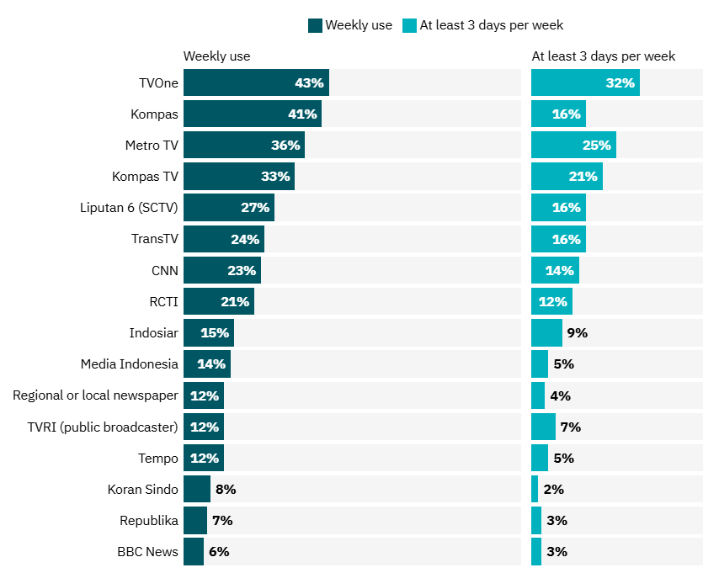

Figure 1.3 Media Reach Offline per Week in Indonesia (TV, Radio, Print)
Source: Reuters Institute Digital News Report 2024

Meanwhile Tempo.co has the better position in the 9th ranking as the choice of Indonesian online readers. The result of survey also mentioned the 15% of all total Indonesian readers access Tempo.co every week.
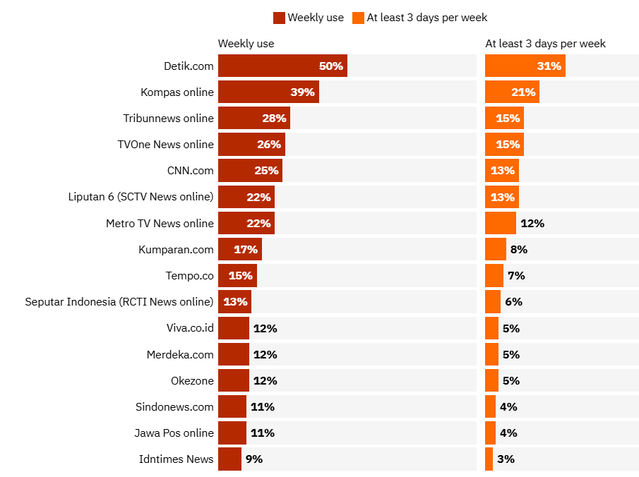

Figure 1.4 Media Reach Online per Week in Indonesia
Source: Reuters Institute Digital News Report 2024

Reuters Institute Digital News Report 2024 also give interesting insight about the trend how the Indonesian readers access source of news from the year 2021 to 2024. Figure 1.5 below shows that online media (including social media) isthe biggest source of news (79%) in Indonesia in 2024, followed by social media (60%), TV (48%) and printing news (9%). While the trend is declining for all outlets in four years, but the number is still dominated by online news.
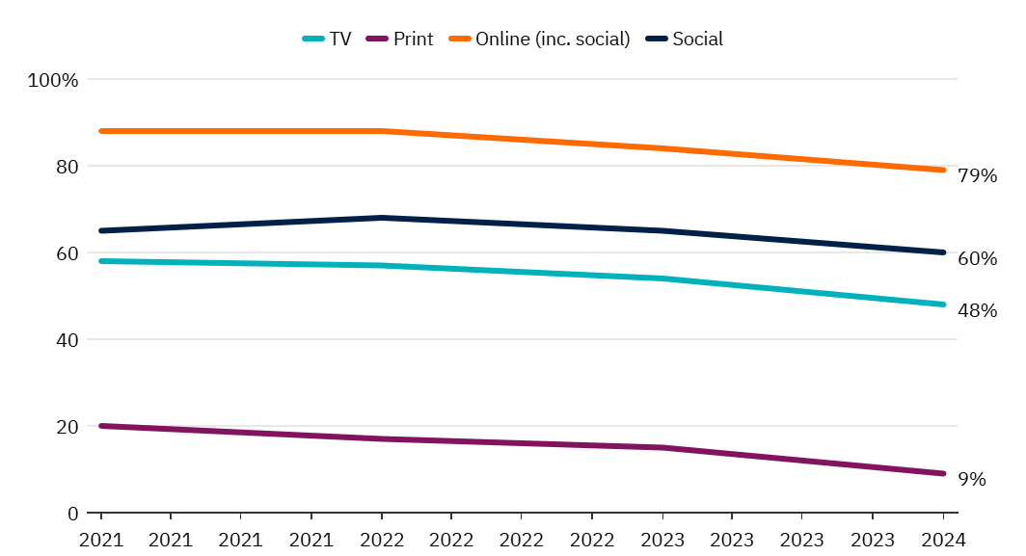
Figure 1.5 Source of News in Indonesia 2021-2024
Source: Reuters Institute Digital News Report 2024

According to Steele (2023), Facebook, and Instagram also support the fact that 60 percents of Indonesians report getting news from social media platform. Data showed that TikTok gained in popularity as a source for news, increased 7 percentage points from 22 to 29 percents, while WhatsApp continued to dominate as the overall social media platform for any use (see below Table 1.1).

Table 1.1 Top Social, Messaging and Video Networks in Indonesia

Rank | Brand | For News | For Any Purpose
1 | WhatsApp | 46% (-5) | 72%
2 | YouTube | 41% (-7) | 65%
3 | Facebook | 35% (-3) | 52%
4 | Instagram | 29% (-8) | 49%
5 | TikTok | 29% (+7) | 44%
6 | X (Formerly Twitter) | 12% (-9) | 20%

Source: Reuters Institute Digital News Report 2024

The struggle in this media has been very hard. Not only facing a large number of reputable media companies from in or outside of Indonesia which targeting the similar audience, they also aim for the biggest possible revenue. Not only that, TEMPO must also battle with non-medias which act like 'spreading the so-called-news’, opinions and also hoaxes.
In order to mitigate technology disruption and to be able to survive in this very challenging industry, TEMPO (established in 1971) which was broadly known as its weekly printing media Majalah TEMPO lately had done some of the steps in digital transformation to be an authoritative and independent media company. One way to do it is by cutting its dependence on ad revenue by switching from traditional to subscription-based model.
Aligned with the corporate turnaround strategy, one of the TEMPO’s ways to enhance digital transformation was by nurturing Tempo's subsidiary company called PT Dimensi Idea Kreatif (TV TEMPO). According to TEMPO Annual Report 2023, TV TEMPO’s operating income by last year reached Rp 191 million, grew 5,1% than 2022. Table 1.2 shows TV TEMPO supported company's income which also came from circulation and advertising of Majalah TEMPO (Rp 8,36 billion or grew 16,2%) and Tempo.co (Rp 5,74 billion or grew 10,4%).
In the same time, circulation and advertising of Koran Tempo declined 16% to Rp 1,4 million, printing business declined by 32,2% to Rp 22 billion and paper business declined 89% to Rp 6,7 billion.
Table 1.2 Performance per Product of TEMPO in 2020-2023

 | 2020 | 2021 | 2022 | 2023 | Deviation
Revenue from Ads 2020-2023 (Rp Billion) |  |  |  |  | Rp (Billion) | %
Majalah Tempo | 22.1 | 29.6 | 26.1 | 34.6 | 8.5 | 32.6%
Koran Tempo | 15.6 | 8.6 | 8.3 | 6.4 | (1.9) | -22.8%
Teco | 30.1 | 38.1 | 51.9 | 57.1 | 5.2 | 10.1%
Amount | 67.7 | 76.3 | 86.2 | 98.1 | 11.8 | 13.7%
Performance per Product
Majalah Tempo | 49.234 | 53.961 | 51.818 | 60.187 | 8.369 | 16.2%
Koran Tempo | 19.800 | 9.345 | 8.693 | 7.261 | (1.432) | -16.5%
Teco | 32.952 | 41.460 | 55.290 | 61.038 | 5.748 | 10.4%
Printing | 52.171 | 51.222 | 68.902 | 46.715 | (22.188) | -32.2%
Event Organizer | 6.869 | 8.851 | 8.499 | 19.474 | 10.976 | 129.2%
Paper | 10.715 | 7.008 | 7.594 | 838 | (6.756) | -89%
Rumah Kreatif | 19.906 | 14.845 | 6.568 | 8.402 | 1.834 | 27.9%
Tempo Channel & TV Tempo | - | 2.434 | 3.734 | 3.925 | 191 | 5.1%
Rombak Media |  |  |  | 8.925 | 8.925 | 0.0%
Total | 191.647 | 189.126 | 211.098 | 216.765 | 5.667 | 2.7%

Source: TEMPO Annual Report 2023

The programs of TV TEMPO related to journalistic products varies from podcast programs in YouTube like Bocor Alus Politik and Jelasin Dong!, to several types of contents like Putar Balik, Di Balik Berita Tempo, Tempo Explained and Cek Fakta succeeded in attracting a great number of audiences and contributed significant for a stable growth of Tempo revenue (Table 1.3).

Table 1.3 Performance of News-Based Playlist Title of TV Tempo YouTube in 2024

No. | Playlist Title | Views | Average View Duration | Estimated Revenue (Rupiah)
1 | Bocor Alus Politik* | 60,970,096 | 0:13:15 | 859,179,664
2 | Tempo Update* | 24,400,668 | 0:01:01 | 26,361,636
3 | Daily News shorts | 9,402,366 | 0:00:38 | 2,339,444
4 | Opini TEMPO* | 7,896,604 | 0:03:14 | 54,590,201
5 | PUTAR BALIK* | 5,249,608 | 0:06:27 | 51,640,991
6 | Jelasin Dong!* | 5,133,752 | 0:09:57 | 69,498,965
7 | Cek Fakta | 2,872,101 | 0:02:07 | 3,634,389
8 | Pemilunesia | 1,092,073 | 0:14:54 | 11,328,533
9 | Dokumenter Tempo | 769,330 | 0:08:13 | 2,537,739
10 | Ada Apa Hari Ini | 702,477 | 0:02:36 | 3,046,332
11 | Tempo EXPLAINED | 466,710 | 0:02:49 | 2,049,417
12 | Di Balik Berita TEMPO | 407,678 | 0:07:13 | 7,050,797
13 | Bikin Ngeri [BARU] shorts | 283,194 | 0:00:39 | 63,133
14 | Oh, Gitu! | 263,344 | 0:01:21 | 959,953
15 | Debat Capres Kedua | Pemilunesia | 221,595 | 0:09:33 | 910,728
16 | ARSIP TEMPO shorts | 209,217 | 0:00:43 | 28,001
17 | Cakap-cakap | 195,063 | 0:04:42 | 1,461,461

Source: Tempo, processed (2025)
*: Contents that will be analyzed further in this research

If we dig deeper about performance data of TV TEMPO YouTube in 2024, it is clearly seen that number of subscribers, views and estimated revenue fluctuated per month. Internal data shown in Table 1.3 shows per 21 November 2024, TV TEMPO YouTube had 629.506 subscribers, 161.796.243 views and the estimated revenue amounts Rp 1,17 billion.
Table 1.4 Monthly Performance of TV TEMPO YouTube in 2024

Month | Subscribers | Views | Average View Duration | Estimated Revenue (Rupiah)
Total | 629,506 | 161,706,243 | 0:06:27 | 1,166,407,682
January | 79,213 | 21,522,225 | 0:04:32 | 79,817,780
February | 88,552 | 22,263,239 | 0:05:42 | 119,913,100
March | 40,401 | 11,795,593 | 0:06:01 | 79,189,947
April | 11,765 | 6,240,753 | 0:04:23 | 35,223,470
May | 16,927 | 6,462,871 | 0:06:17 | 49,324,961
June | 28,473 | 8,838,756 | 0:07:10 | 80,872,329
July | 39,621 | 10,225,499 | 0:06:19 | 79,473,319
August | 168,379 | 28,264,613 | 0:08:14 | 231,640,911
September | 65,713 | 17,728,842 | 0:06:46 | 153,038,840
October | 69,871 | 20,919,762 | 0:07:04 | 181,854,340
November (21st) | 20,591 | 7,444,090 | 0:06:51 | 76,058,684
Source: Tempo, processed (2025)

1.2 Research Problem
Responding to the latest trend, TEMPO should be more consumer-focused too since their behaviour change rapidly. Their needs which become more sophisticated, while so many options of source and style of information can be accessed more easily nowadays—must also be anticipated. Because failure in grabbing the potential market will lead to potential loss of opportunity in the future.
In this fast-changing era, there should be a quick decision-making process to prioritize, develop and produce the most potential news product to be delivered to public as soon as possible. In terms of YouTube channel—which contributes significant growth—TV TEMPO management needs to set the prioritization list contains programs to be produced in first, second, third place and so son based on their potential revenue to company.
Many studies already brought up issues related to audience preferences for journalistic product and marketing strategies applied in media industries. However, the research focused on determination of the criteria in YouTube content creation to improve organizational performance is still rare, primarily mentioning TV TEMPO.
The research becomes more important since YouTube platform enhancement is very important to be a front gate to welcome the new and loyal TEMPO audience and lead them to be a subscriber so they can explore more premium journalism products of TEMPO. TEMPO believed on this subscription business model will make the company truly independent.

1.3 Research Question
According to the fact that there is no specific research focused on determining the main criteria in TV TEMPO YouTube program creation to improve organizational performance, this study is proposed to fill the gap. This study sets out to investigate the research question: “What are the main criteria to be considered in creating TV TEMPO YouTube program by exploring deeply from judgement of experts in Analytical Hierarchy Process (AHP)? What are the best YouTube programs to be recreated in the future?”

1.4 Research Objectives
By addressing the questions above, this research aims to provide comprehensive understanding of the key criteria to be considered in creating TV TEMPO YouTube content and best programs to be recreated in the future. The other output of research is a strategic planning for fostering innovation and development of the TV TEMPO YouTube content in the future.

1.5 Research Contributions
This study tries to give contributions by answering the problems faced by the public and TV TEMPO by producing best quality journalism product that bridge the interests of both. The result of this research is not only to help readers get credible news and best journalism products but also allows media companies to survive in this digital era.

1. TEMPO
This research will provide strategies to improve performance of TV Tempo YouTube program, not only for the existing content, but also in the future development. The prioritization in content creation will make the production process more effective and efficient that lead to maximum result of company revenue, but still hold the integrity in good quality journalism. Because of that, TEMPO can be a leader in news media company market by enhancing unique product which answers public’s need of news.
2. Audience
The audience will get credible facts and data provided by TEMPO. They will get the complete package, because content of TV TEMPO contains multivariant products to meet the needs of each unique audience, from talk show, summarize of daily news, explainer news in audio video formats etc.
3. Public
On the next development, TV TEMPO YouTube program will encourage audience or public to intensively participate in sharing information to be developed as a bottom-up news product and creates public discourses that also give inputs to government and related stakeholders.
4. Academic and Research Organization
This study will provide recommendation not only for company, but also to academic field and research organisation for further development. TV TEMPO YouTube program will enable people to reach the good quality journalism products and share them more widely. It is also can be studied further in academic researches. People will get an easy access to research through digital format and attractive design.

1.6 Research Scope
The scope of thesis is limited to five programs of TV TEMPO which records the highest views, average view duration and estimated revenue. They are: Bocor Alus Politik, Tempo Update, Opini TEMPO, PUTAR BALIK, Jelasin Dong! Then, there will be a literature review to determine the criteria and sub-criteria to be analyzed by the experts.
In this research, there will be twenty one experts from different background to be interviewed as a main source in Analytical Hierarchy Process (AHP). They will give a comprehensive analysis and enrich the qualitative survey that will be held in early March 2025. Then, to complete the research, there will be an interview with the Indonesia Chamber of Commerce and Industry (Kadin) and Indonesia Association Venture Capital and Startup Indonesia (Amvesindo) to get insights about the prospect of digital media industry. Lastly, interview top management of TV TEMPO and PT Tempo Inti Media will be held to analyze deeply about the development of TV TEMPO YouTube programs.

1.7 Structure of the Thesis
Chapter 1 Introduction describes research background, research problem, research question, research objectives, research contributions, research scope, and structure of the thesis.
Chapter 2 Literature Review contains the brief of media industry and business models from optimizing YouTube. This chapter also explain about Analytical Hierarchy Process (AHP) which will be used, process of determining criteria and alternative programs to be analyzed by experts.
Chapter 3 Research Methodology explains about research framework, data collection process, expert profiles, criteria to be analyzed, and protocols before interview.
Chapter 4 Data Analysis and Discussion explains about the process of data analysis and further discussion about it.
Chapter 5 Conclusion and Recommendation contains of summary of what have been discussed in the previous chapters and also some of recommendations for further research.
CHAPTER 2
LITERATURE REVIEW

2.1 Dynamic of Media Industry
This section will discuss the transformation occurring within the news media industry. The evolution of this sector is closely linked to the digital changes driven by swift technological advancements and shifts in consumer behaviour. Traditional news media, which heavily depended on print formats and advertising revenues, has transitioned to digital platforms and adopted subscription-based business models to remain competitive.

2.1.1 Digital Transformation in Media Company
The digital evolution within news media organizations in response to technological disruptions and changing consumer habits is not only happened in Indonesia because it is a global phenomenon. The forms of digital transformation vary, encompassing media convergence, adaptation to digital platforms, and the repackaging of news for publication across multiple channels. Unfortunately, as noted by Lee-Wright et al. (2012), not all companies have thrived; some have failed to survive and have closed down.
With the rapid advancement of digital technology, news consumers have also transformed from passive viewers to active participants. Research indicates that consumers increasingly desire personalized news offerings and on-demand content accessible across various devices. For instance, recent findings from the Pew Research Center (Atske, 2024) reveal that 86% of American adults occasionally obtain news via smartphones, computers, or tablets, followed by television (63%), radio (42%), and print media (26%). This shift compels media companies to adapt and enhance the accessibility of news for their audiences.
Additionally, the digital transformation in news media is a response to the decreasing traditional revenue streams due to intensified competition from digital giants like Google and Facebook. According to the latest survey by the World Association of News Publishers (WAN-IFRA), print still constitutes the largest revenue source. On average, as reported by Henriksson (2025), print circulation and advertising account for 45% of respondents’ revenues, marking the first instance in research history where this figure has dipped below 50%.
Technological disruptions, as discussed by De-Lima-Santos & Ceron (2021), have also prompted news media companies to enhance their resources, utilizing tools such as artificial intelligence (AI), big data analytics, and machine learning. These innovations enable companies to provide more personalized content, streamline workflows, and improve user experiences. Conversely, failure to adopt these advancements may result in falling behind competitors who deliver quicker and more relevant content.

2.1.2 Shifting to a Subscription-Based Model
The transformation within news media companies extends beyond how they deliver products to meet evolving consumer expectations; it necessitates a shift from advertising-based revenue models to subscription-based frameworks, particularly as traditional media companies grapple with declining ad revenues and aggressive online content providers.
An example of this transition is The New York Times (Kumar et al., 2012), which began requiring users to pay for digital or print subscriptions in March 2011 after exceeding 20 free articles per month. This decisive move was a response to a decade of declining revenues, as online advertising alone failed to compensate for the loss of print income.
This strategic pivot proved successful, leading The New York Times (Fatemi, 2024) to report significant growth in subscription revenue. By 2022, the company generated $2.3 billion in total revenue, with subscriptions—both print and digital—accounting for 67% ($1.55 billion) of this figure, and 63% derived from digital subscriptions.
Advertising revenues (from both print and digital) contributed $523 million, or 22.7%. This transition has not only stabilized the company’s income streams but has also empowered The New York Times to reinvest in innovative journalism. Other news media organizations, such as The Washington Post, The Wall Street Journal, Financial Times, and The Guardian, have similarly succeeded in their transformations.

2.2 New Opportunity via YouTube
Over time, social media platform (Bisht, et al, 2019) have opened substantial growth opportunities for organizations by fostering communication with clients and facilitating social interactions on online business platforms. Among these, YouTube has emerged as a favoured platform, particularly among younger audiences, becoming a significant player in the social media landscape.
YouTube allows users to upload content for free viewing, subsequently monetizing videos through an advertising-based revenue model. PT Tempo Inti Media Tbk. has recognized YouTube as a viable platform for supporting news production also. The company not only converts text-based journalistic content into audio-visual formats but also continually produces original programming (IP) to attract a broader audience. As noted in the Tempo Annual Report 2023, this approach responds to rising printing costs and a diminishing audience for traditional media.
Consequently, in recent years, news products in video format—ranging from short to long, and light to in-depth—have increasingly been featured on the @Tempodotco YouTube channel. These multimedia presentations are integrated into articles, providing readers with both textual and audiovisual content.
A study by Setiawan et al. (2020) suggests that YouTube is progressively replacing traditional television as a source of media consumption. Viewers cite four primary reasons for their shift from television to YouTube and other social media: informational interest, personal identification, social integration and connection, and entertainment, which collectively account for approximately 84.18% of their motivations.
The rise of YouTube and similar platforms has begun to challenge television's traditional dominance. For millennials, social media is increasingly supplanting mass media in providing knowledge and entertainment.
Despite this, mass communication experts remain optimistic about television's longevity, as social media primarily redistributes content rather than creates it. Moreover, television programming still plays a pivotal role in content creation, and the way audiences consume television has evolved. Viewers can watch TV at their convenience, without being bound to traditional broadcast schedules, and many do so from devices other than conventional television sets. This shift impacts revenue for companies reliant on television programming.

2.3 Analytical Hierarchy Process (AHP)
The Analytical Hierarchy Process (AHP) is a widely recognized method for addressing multi-criteria decision-making challenges, developed by Saaty in 1980. Its user-friendly nature and ability to integrate qualitative and quantitative data effectively (Iancu, 2021) contribute to AHP's relative ease in managing various criteria.
AHP involves a three-step decision-making process (Canco et al., 2021). The first step involves structuring the model, which entails decomposing a complex issue into a hierarchy of distinct elements. The second step focuses on comparing criteria and alternatives, followed by calculating weights to establish priorities among these elements. The third step synthesizes these priorities to arrive at a final decision. AHP provides a framework for navigating scenarios with multiple criteria, encompassing both tangible and intangible, qualitative and quantitative aspects.
To clarify the previously discussed process, the following graph illustrates the workflow of AHP. Essentially, the first step of AHP is to break down a complex problem into sub-problems arranged hierarchically, with specific criteria assigned to each sub-problem.
The top level of the graph signifies the overall goal, which consists of a single element—the main objective. In the context of this study, the primary aim is to identify essential criteria for developing TV TEMPO YouTube programs. Subsequent levels list all performance measures necessary to reach the goal.
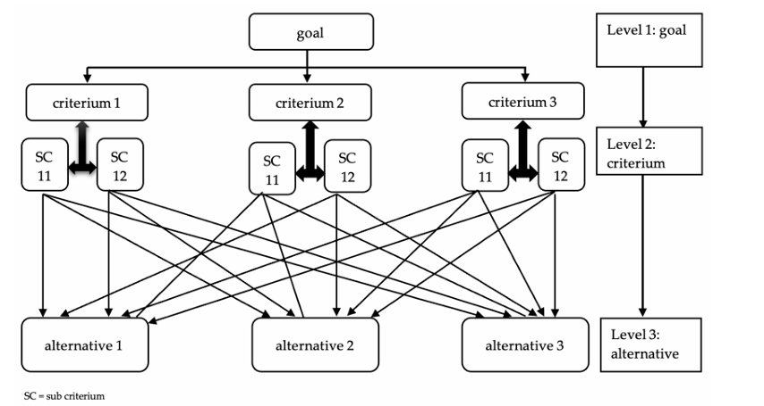
Figure 2.1 The Structure of AHP Method
Source: Saaty (1980)

The figure above depicts the three levels of the AHP hierarchy. Level 1 represents the goal of the analysis, which guides the arrangement of alternatives. Level 2 involves the evaluation of criteria, assessing their relative importance. Level 3 focuses on the assessment of alternatives based on the significance of each.
After structuring the problem, the next step (IJSRD - International Journal for Scientific Research and Development, 2014) involves comparing each element within the corresponding level and calibrating them using a numerical scale. This process requires n*(n-1)/2 comparisons, where n denotes the number of elements, taking into account that diagonal elements are equal to “1,” while the remaining elements represent the reciprocals of the previous comparisons.
Following this, calculations are performed to determine the maximum Eigenvalue, consistency index (CI), consistency ratio (CR), and normalized values for each criterion/alternative. If the maximum Eigenvalue, CI, and CR meet satisfactory standards, decisions are made based on the normalized values; otherwise, the procedure is repeated until the values fall within the desired range.

2.3.1 The Advantage of AHP
One of the most crucial steps in many decision-making methods is the accurate estimation of the pertinent data. This is a problem not bound in the AHP method only, but it is crucial in many other methods which need to elicit qualitative information from the decision-maker. Very often qualitative data cannot be known in terms of absolute values.
Information about questions is vital in making the correct decision, it is very difficult, if not impossible, to quantify them correctly. Therefore, many decision-making methods attempt to determine the relative importance, or weight, of the alternatives in terms of each criterion involved in a given decision-making problem. incorporate a group consensus.
The Table 2.1 below shows a comparison scale listed. It summarizes the determination of the evaluation of the individual criteria with the preference rate from which the criteria are selected for the construction of the matrix.

Table 2.1 AHP Pairwise Comparison Table

Relative Importance | Definition | Explanation
1 | Equal Importance | Two activities contribute equally to objective
3 | Weak Importance | Experience and judgment slightly favour one activity over another
5 | Strong Importance | Experience and judgment strongly favour one activity over another
7 | Demonstrated Importance | One activity is strongly favoured and demonstrated in practice
9 | Extreme Importance | The evidence favouring one activity over another is of highest possible order of affirmation
2, 4, 6, 8 | Intermediate Values | When compromise is needed between two adjacent judgments

Source: Saaty (1980)

2.3.2 Previous Studies
From literature study, we can see and compare the usage of AHP in previous researches, including the methods and plus-minus related with the proposed research. Table 2.2 below contains summary of literatures that compare usage of Analytical Hierarchy Process (AHP) in decision making.
Table 2.2 Summary of Literatures Comparing Usage of AHP

No | Title | Method | Plus - Minus
1 | Designing an Integrated AHP Based Decision Support System for Supplier Selection in Automotive Industry | Supplier selection Analytic hierarchy process (AHP) Supply chain management Multi criteria decision making (MCDM) Sensitivity analysis Decision support system | Plus:  This journal discusses in detail the DSS process using AHP which can be used as a reference by the author in writing research.  Minus:  Journal is focused only on transportation
2 | Combining Analytic Hierarchy Process (AHP) with Role Playing Games for Stakeholder Engagement in Complex Transport Decisions | Multicriteria decision-making; stakeholder involvement; participatory process; transport planning | Plus:  This journal discusses in detail the DSS process using  AHP which the author can use as a reference in writing research  Minus:  Scope of discussion in this journal is about transportation
3 | Analytic Hierarchy Process Decision Making Evaluation of Retail Service Quality- A Fuzzy AHP Approach Algorithm | Analytical Hierarchy Process (AHP), Multi Criteria Decision Making (MCDM) | Plus:  The journal discusses various methods in  decision making and  explains various derivatives andtypes of decision-making methods.  Minus:  This journal focuses  more on AHP theory, does not overly discuss the implementation of AHP calculations.
4 | Evaluation of Retail Service Quality- A Fuzzy AHP Approach | Analytical Hierarchy Process, Fuzzy Numbers and Triangular Fuzzy Numbers (TFNs) | Plus:  The cases in this journal  have similar methods  to the author  Minus:  This journal discusses more  about service quality,  while researchers will discuss more about YouTube content.
5 | A Web Based Decision Support System for Multi Criteria Inventory Classification using Fuzzy AHP Methodology | Multi-criteria inventory classification, Fuzzy AHP methodology, Fuzzy preference programming, Decision support system | Plus:  This journal discusses  about solving the problem of  decision making in selecting  shopping malls, which  has the same goal as the author's research, namely  choosing shopping malls, but the difference is that the author's research is to determine its best performance.  Minus:  Journal does not explain the purpose of selecting YouTube content. It only explains the criteria for selecting a mall
6 | AHP Technique a Way to Show Preferences Amongst Alternatives | Literature review on how to do AHP technique and some of illustrations are included. | Plus:  Journal observes AHP is being predominantly used in the theme area of selection and evaluation, also the benefit and limitation of AHP.  Minus:  Journal does not specific explains how to use AHP technique
7 | Application of Fuzzy Analytical Hierarchy Process in the Selection of Social Networking Sites | Analytical Hierarchy Process, Fuzzy Numbers and Triangular Fuzzy Numbers (TFNs) | Plus:  This journal discusses in detail the DSS process using AHP which can be used as a reference by the author in writing research.  Minus:  Journal is focused only on social networking sites (SNS)
8 | Analysis of Flood Disaster Risk Factors with Geographic Information System (GIS) Method and Analytical Hierarchy Process (AHP) in Bekasi City | Geographic Information System (GIS) Method and Analytical Hierarchy Process (AHP) | Plus:  The journal details in explanation on combining GIS and AHP in calculating flood risk based on hazard and vulnerability  Minus:  Journal only focuses on GIS data and not deeply discuss about the social aspect as one of a cause of flood disaster
9 | Political YouTube Channel Reputation (PYCR): Development and Validation of a Multidimensional Scale | In-depth interviews with 32 experts and empirical findings from 380 adults | Plus:  The four findings and theoretical framework of the journal could be significant input for author’s research  Minus:  Scope of study is in South Korea, which will not be universal if it used in another country and socio-aspect related.
11 | AHP Approach for Determining Category in Social Media Content Creation in Order to Maximize Revenue per Mille (RPM) | Linear regression, AHP Weight Calculation | Plus:  The categories and subcategories in this journal could be used for author’s research  Minus:  Journal does not include consideration on social media content creation’s effect on non-revenue aspect
12 | The Determinant Factors of Television’s Audience in Choosing TV Channel in the Disruptive Era | Focus Group Discussion (FGD) involved 51 participants | Plus:  Journal found 23 determinant factors that influence viewers in choosing TV channels. Some of the factors can be used for author’s research  Minus:  There should be adjustment for the next research, since the FGD was held before pandemic Covid-19 occurred.

Source: Author, processed (2025)

2.4 Criteria, Sub-Criteria and Alternative
2.4.1 Criteria and Sub-Criteria
Below is Table containing summary of literature review defining criteria and sub-criteria on TV TEMPO YouTube content to be ranked in AHP. Based on literature study, we come up with four criteria and 10 sub-criteria. The four criteria are quantitative, qualitative, production and SEO score. The ten sub-criteria are number of subscribers, click-through rate (CTR), conversion rate, views, user rating, number of interaction rate, cost, production, number of words on title and number of tags used in description of video.

Table 2.3 Criteria and Sub-criteria on YouTube Content Analysis

No | Criteria and Sub-Criteria | Definition | Source
A | Quantitative
A1 | Subscriber, Follower | User who intentionally opts in to receive regular updates and notifications regarding new uploads or activities from a specific channel | Schwemmer & Ziewiecki, 2018  Grave, 2019
A2 | Click-Through Rate | analytic ratio that represents the proportion of users who engage with a hyperlink, advertisement, or video by clicking on it after seeing it, typically expressed as a percentage | Grave, 2019
A3 | Conversion Rate | reflects the success of digital strategies by measuring the percentage of users who take a desired action out of the total number of visitors, sessions, or exposures—'conversions' may denote subscribing, purchasing, signing up, or any predefined interaction | Grave, 2019
A4 | Views | single instance where a user initiates playback of a video and the platform’s algorithm recognizes the interaction as legitimate (not artificially repeated or automated) | Schwemmer & Ziewiecki, 2018
B | Qualitative
B1 | User Rating | aggregate evaluative scores or feedback (such as “likes” or “dislikes”) provided by viewers in response to a YouTube video | Guzman and Robielos (2022)
B2 | Interaction Rate | the proportion of audience members engaging with content beyond mere viewing, most commonly through actions such as liking, commenting, sharing, and subscribing | Grave, 2019
C | Production
C1 | Cost | aggregate resources (monetary, temporal, technological) allocated for content creation, production, and distribution | Grave, 2019
C2 | Duration | absolute length of a YouTube video, typically measured in minutes and seconds | Schwemmer & Ziewiecki, 2018
D | SEO Score
D1 | Title Word Count | quantitative measure of how many words appear in a YouTube video’s title | Lopezosa, C et al (2019), Guzman and Robielos (2022)
D2 | Tags | metadata elements attached to YouTube videos, comprising keywords or short phrases describing the video’s topical scope, genre, or key entities | Lopezosa, C et al (2019)

Source: Grave (2019), Guzman and Robielos (2022), Lopezosa et al (2019),
Schwemmer et al (2018), processed

2.4.2 Alternative
The next table will show the alternative of programs of TV TEMPO YouTube to be ranked in AHP. The prioritization of TV TEMPO YouTube program is needed as a base of decision in reproducing the similar content in the future. Based on interview result with the TV TEMPO stakeholder and literature study, we come up with four alternative programs. The four alternative programs are talk show, video, editorial and explanatory.

Table 2.4 Alternative Program of TEMPO TV YouTube

No | Alternative | Definition | Source
1 | Talk Show | Audiovisual program centered on dialogical interactions between a host and guests (such as experts, influencers, or celebrities), structured around the exchange of opinions, lived experiences, or thematic discussion topics
2 | Video | Characterized as modular, visual-auditory communication organized for entertainment, information, education, or community-building
3 | Editorial | Video media in which the creator provides analysis, commentary, or subjective evaluation on news, trends, products, or sociopolitical phenomena. It is an “opinion-forming,” distinguished by a recognizable authorial voice, transparency in viewpoint declaration, and reliance on credible sources or citations
4 | Explanatory | Structured audiovisual genre that seeks to popularize, clarify, or demystify complex phenomena for public consumption

Source: Author, processed (2025)

CHAPTER 3
RESEARCH METHODOLOGY

3.1 Research Framework
This chapter starts with the explanation about research framework which is used in this research. Figure 3.1 below shows the frameworks starts with problem identification contains of determining research topics, collecting literature and formulating research objectives. Then research will use Analytical Hierarchy Process (AHP) as a analysis tool, and in the end we get the result of key criteria in TV TEMPO YouTube content creation and recommendation for further development.
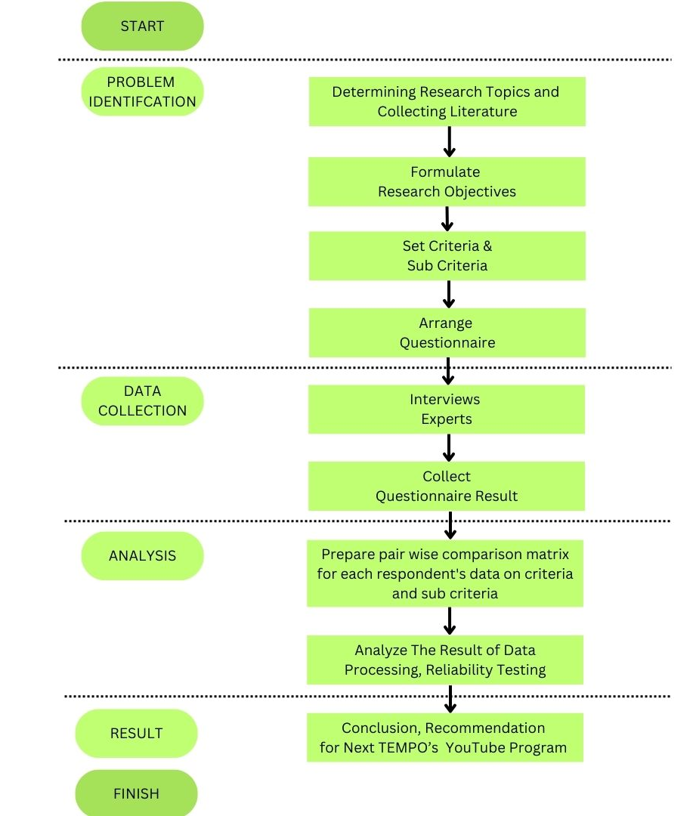
Figure 3.1 Research Framework
Source: Author, processed (2025)

3.2 Collection Data Process
3.2.1 Primary Data
We use primary data in this research. To get the data, we ask 21 experts to fill out questionnaire form. They are youtubers or content creators, digital media industry, SEO specialists, digital marketing experts, academists from public communication field and socio-politics analysts or practitioners, representatives of gen Z and generation millenial. The form of questionnaire was sent to the experts in mid-May-July 2025 via Google Form. The collection and analysis of data will be held on the mid to the end week of July 2025 by using software Microsoft Excel or Expert Choice.
The data gathered consists of rating of the criteria and alternatives to be considered in creating TV TEMPO YouTube content. The rating of criteria and alternatives from each expert will be presented as shown in Table 3.2 below.

Table 3.1 Rating from Experts
No | Respondent | Criteria | Alternatives
1 | YouTuber, Content Creator (3)
2 | Digital Media Industry (3)
3 | SEO Specialist (3)
4 | Digital Marketing (3)
5 | Academist, Socio-politics Expert (2)
6 | Gen Z (3)
7 | Gen X, Milenial (4)

Source: Author, processed (2025)

Via Google Form, 21 experts filled out the questionnaire in ranking the criteria and program alternatives to be considered in creating TV TEMPO YouTube content. First, they filled the ranking based on the scale of relative importance mentioned on the Table 2.1 earlier.
The summary of scale importance between two criteria and alternative is: scale 1 for equal importance, scale 3 for weak importance, scale 5 for strong importance, scale 7 for demonstrated importance, and scale 9 for extreme importance. The expert could also choose scale 2, 4, 6, or 8 as an intermediate value.
Other than questionnaire, there will be interviews with Indonesia Chamber of Commerce and Industry (Kadin) and Indonesia Association Venture Capital and Startup Indonesia (Amvesindo) to get insights about the prospect of digital media industry.

3.3.2 Secondary Data
The secondary data in this research is needed to complete series of analysis. For AHP, secondary data to be collected is needed not only to give a clear problem background and context of the questionnaire material but as a supporting data for the whole research. Those data was collected from data statistic from government or private sectors and published research reports.

3.4 AHP Model

To give a clear picture of the main steps to do in AHP, we provide the Figure 3.2 that shows the main objective or goal of the research, list of criteria and sub-criteria, and the last ones are four alternatives. The main objective is to find key criteria to be considered in creating TEMPO YouTube content and programs in prioritized number. The list of criteria and sub-criteria consists of four and ten item. Next, is the four alternatives are: talk show, video, editorial and explanatory.
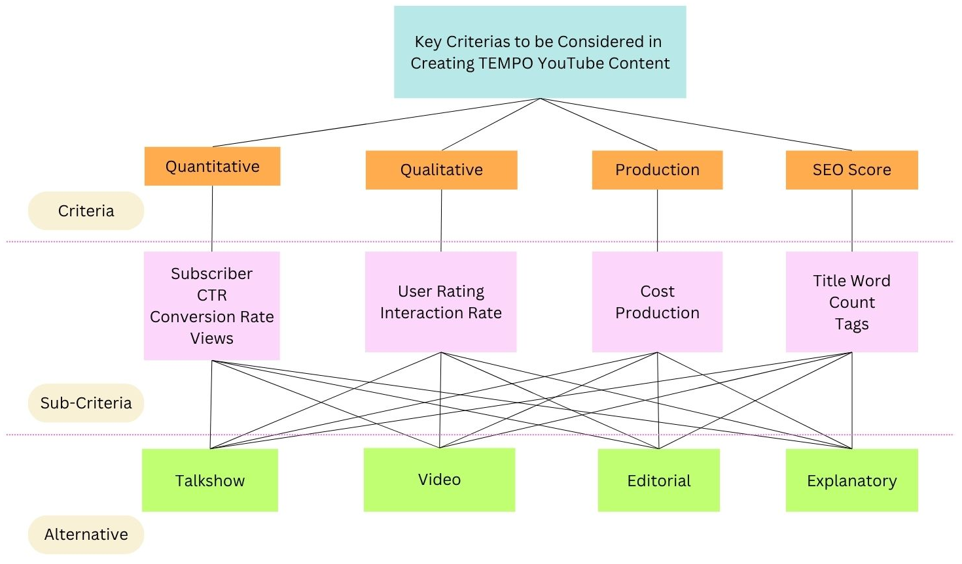
Figure 3.2 Hierarchical Diagrams in Determining Key Criteria in
TEMPO TV YouTube Content Creation
Source: Author, processed (2025)

3.4.1 Steps in AHP
One of the research objectives is to rank the main criteria to be considered in creating TEMPO YouTube content among experts using AHP. The necessary steps are explained in detail and shown in Figure 3.3 below.

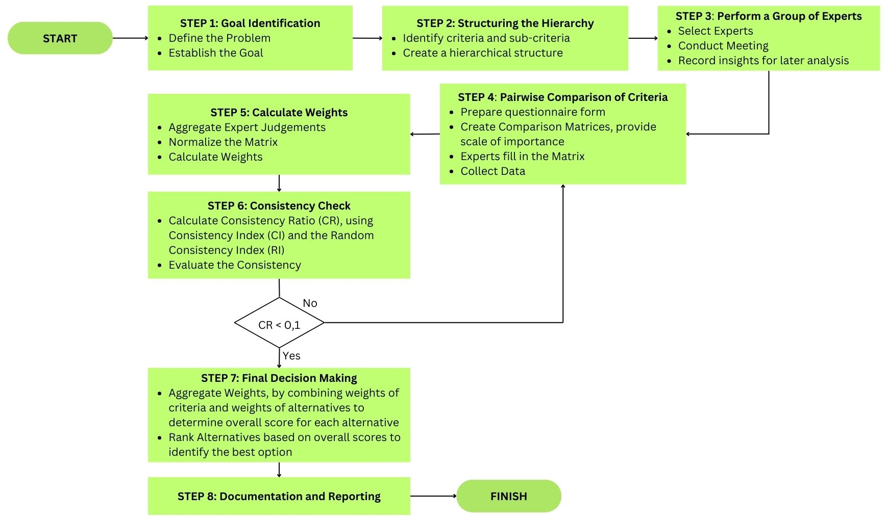

Figure 3.3 Flowchart for Problem Solving using AHP Model
Source: Processed by Author (2025)

The flowchart above shows at least there is 8 steps to be taken in problem solving using by AHP. The following steps are:
Step 1: Goal Identification. In this step, we refresh the research problem identification and establish goals to achieve.
Step 2: Structuring the Hierarchy. The process of structuring starts by identifying criteria and sub-criteria and then creating a hierarchical structure.
Step 3: Perform a Group of Experts. In this step we select five experts, conduct meeting by offline or online to record their insights about this research.
Step 4: Conduct Pairwise Comparison of Criteria. First, we prepare questionnaire form in Google Form which consists of comparison matrices and scale of importance of criteria and sub-criteria. After the experts complete in filling out the matrix and submit the form, we collect the data.
Step 5: Calculate Weights. After collecting the data, then we aggregate judgements of experts, normalize the matrix to ensure they sum to 1 for each criterion and calculate weights by deriving the priority weights for each criterion and alternative from the normalized values. It can be seen on Table 3.4 below.

Table 3.3 Matrix Preferred Comparison A (nxn)

 | A1 | A2 | A3 | ... | An
A1 | 1 | W1/W2 | W1/W3 | ... | W1/Wn
A2 | W2/W1 | 1 | W2/W3 | ... | W2/Wn
3 | W3/W1 | W3/W2 | 1 | ... | W3/Wn
n... | ... | ... | ... | ... | ...
An | Wn/W1 | ... | ... | ... | 1

Source: Author processed (2025)

Step 6: Consistency Check. In this step we calculate Consistency Ratio (CR) by using Consistency Index (CI) and the Random Consistency Index (RI) which is shown in Table 3.5, then evaluating the consistency. According to Saaty (1980), the rule of thumb is if CR < 0,1 or 10%, then the judgement of expert is considered acceptable. In the contrary, if CR > 01, we should go back to Step 4.

Table 3.4. Saaty’s Random Consistency Index (RI)
N | 1 | 2 | 3 | 4 | 5 | 6 | 7 | 8 | 9 | 10
Random Index (RI) | 0 | 0 | 0.58 | 0.90 | 1.12 | 1.24 | 1.32 | 1.41 | 1.45 | 1.49

Source: Saaty (1983)

Step 7: Final Decision Making. For final decision-making step, we aggregate weights of the criteria with the weights of the alternatives to determine the overall score for each alternative. After that, we rank the alternatives based on their overall scores to identify the best option.
Step 8: Documentation the entire AHP process, including step of perform the hierarchy, pairwise comparisons, calculation and final recommendation.

3.4.2 Questionnaire
After determining curated criteria and alternatives, we formulate the checklist table to be ranked by twenty one experts. But first, we provide the brief explanation about the instruction for the experts before doing the ranking. The expert must fully understand the scale of relative importance before filling out the questionnaire. The detail activity of filling out the questionnaire and the forms will be explained on the Appendix chapter.
For example, the expert should fill the scale (give a mark √) on the left if element X has a higher level of importance than element Y. On the contrary, the expert should fill the scale on the right if element Y has a higher level of importance than element X. The following Table 3.5 shows an illustration to be shown to experts in how to fill out the questionnaire form.

Table 3.5 Illustration of Questionnaire Form

Code | Criteria | Scale |  |  |  |  |  |  |  |  | Scale |  |  |  |  |  |  |  |  | Criteria | Code
Code | Criteria | 9 | 8 | 7 | 6 | 5 | 4 | 3 | 2 | 1 | 1 | 2 | 3 | 4 | 5 | 6 | 7 | 8 | 9 | Criteria | Code
A7 | View |  |  |  |  |  |  |  |  |  |  |  |  |  |  |  |  |  | √ | Conversion Rate | A5
A7 | View |  |  |  |  |  |  | √ |  |  |  |  |  |  |  |  |  |  |  | Quality | B5
A7 | View | √ |  |  |  |  |  |  |  |  |  |  |  |  |  |  |  |  |  | Subscriber | C2
Element X Element Y
Source: Author, processed (2025)
CHAPTER 4
DATA ANALYSIS AND DISCUSSION

4.1 Data Analysis
4.1.1 Profile of Respondent
4.1.1.1 Stratified Simple Random Sampling
This section will discuss the reason of choosing stratified simple random sampling in this research.
4.1.1.2 Composition of Respondent
This section will discuss the the composition of respondents/experts who filled out questionnaire.
Table 4.1 Area of Expertise of Respondents

Field of Expertise | Number | Percentage (%)
Youtuber/Content Creator | 3 | 14,3
SEO Specialist | 3 | 14,3
Digital Media | 3 | 14,3
Academist | 2 | 9,5
Digital Marketing | 3 | 14,3
Gen X and Milenial | 4 | 19
Gen Z | 3 | 14,3
Total | 21 | 100
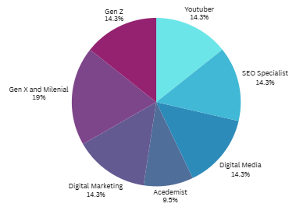
4.1.1.3 Respondent Profile
This section will give a clear picture of the respondent profile, including demographic data such as sex, age, educational background, and job.

Table 4.2 Composition of Respondent

Sex | Number | Percentage (%)
Male | 12 | 54,5
Female | 10 | 45,5
Total | 21 | 100
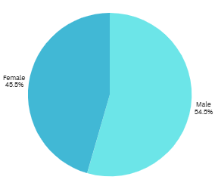

Table 4.3 Composition of Respondent Age

Age | Number | Percentage (%)
17-28 (Gen Z) | 3 | 14,3
29-44 (Gen Milenial | 6 | 28,6
45-above (Gen X) | 12 | 57,1
Total | 21 | 100

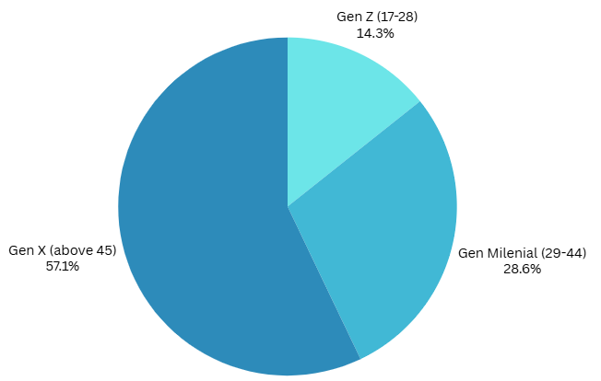

Table 4.4 Composition of Respondent Educational Background

Educational Background | Number | Percentage (%)
D3-D4
S1
S2
Total | 21 | 100

Table 4.5 Composition of Respondent’s Job

Job | Number | Percentage (%)
Student
Employee
Enterpreneur
Total | 21 | 100

4.1.2 Profile of TEMPO YouTube Program
4.1.2.1 Talk Show

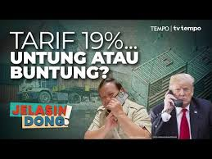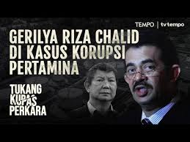

4.1.2.2 Video

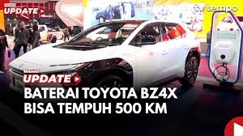
4.1.2.3 Editorial

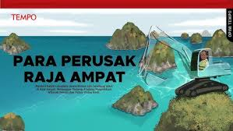
4.1.2.4 Explanatory



4.1.3 Criteria Analysis
4.1.3.1 Hasil Pengisian Kuesioner Matriks Perbandingan Berpasangan
 | Quantitative | Quantitative | Production | SEO Score
Quantitative | 1
Qualitative |  | 1
Production |  |  | 1
SEO Score |  |  |  | 1

4.1.3.2 Matriks Resiprokal Perbandingan Berpasangan
4.1.3.3 Matriks Resiprokal Desimal
4.1.3.4 Matriks Penjumlahan Kolom Tiap Kriteria
4.1.3.5 Matriks Hasil Normalisasi
4.1.3.6 Hasil Akhir Prioritas Kriteria
4.1.3.7 Uji Indeks Konsistensi (CI)
4.1.3.8 Matriks Resiprokal Desimal dg Prioritas Kriteria
4.1.3.9 Hasil Perkalian Matriks Resiprokal Desimal dengan Prioritas Kriteria
4.1.3.10 Lambda Max
4.1.3.11 Uji Konsistensi Ratio (CR)
4.1.3.12 Prioritas Kriteria
Prioritas | Kriteria
 | Quantitative
 | Qualitative
 | Production
 | SEO Score

4.1.4 Alternative Analysis

Quantitative | Talkshow | Videos | Editorial | Explanatory
Talkshow
Videos
Editorial
Explanatory

Qualitative | Talkshow | Videos | Editorial | Explanatory
Talkshow
Videos
Editorial
Explanatory

Production | Talkshow | Videos | Editorial | Explanatory
Talkshow
Videos
Editorial
Explanatory

SEO Score | Talkshow | Videos | Editorial | Explanatory
Talkshow
Videos
Editorial
Explanatory

4.1.4.1 Hasil Pengisian Kuesioner Matriks Perbandingan Berpasangan
4.1.4.2 Matriks Resiprokal Perbandingan Berpasangan
4.1.4.3 Matriks Resiprokal Desimal
4.1.4.4 Matriks Penjumlahan Kolom Tiap Kriteria
4.1.4.5 Matriks Hasil Normalisasi
4.1.4.6 Hasil Akhir Prioritas Kriteria
4.1.4.7 Uji Indeks Konsistensi (CI)
4.1.4.8 Matriks Resiprokal Desimal dg Prioritas Kriteria
4.1.4.9 Hasil Perkalian Matriks Resiprokal Desimal dengan Prioritas Kriteria
4.1.4.10 Lambda Max
4.1.4.11 Uji Konsistensi Ratio (CR)
4.1.4.12 Prioritas Alternatif

Prioritas | Alternative
 | Talk Show
 | Video
 | Editorial
 | Explanatory
4.1.5 Interview with Related Stakeholder

4.2 Discussion

REFERENCE

Journal
De Guzman, K. J., & Robielos, R. a. C. (2022). AHP approach for determining category in social media content creation in order to maximize revenue per mille (RPM), HighTech and Innovation Journal, 3(1), 65–72. https://doi.org/10.28991/hij-2022-03-01-07
Meyer, P. (2005). The vanishing newspaper: saving journalism in the information age. Choice Reviews Online, 42(09), 42–5072. https://doi.org/10.5860/choice.42-5072
Changing journalism. (2011, November 7). Routledge & CRC Press. https://www.routledge.com/Changing-Journalism/Lee-Wright-Phillips-Witschge/p/book/ 9780415579551? srsltid=AfmBOop_KS_6SKvFGAZDCAN224y68cpczNWuRQrorgWYKzW3bKmgpuKq
Crisis communication management in law enforcement support agencies (Study of the Financial Transaction Reports and Analysis Center). (2024a). Jurnal Komunikasi Indonesia, 13(1). https://doi.org/10.7454/jkmi.v13i1.1187
Crisis communication management in law enforcement support agencies (Study of the Financial Transaction Reports and Analysis Center). (2024b). Jurnal Komunikasi Indonesia, 13(1). https://doi.org/10.7454/jkmi.v13i1.1187
Henriksson, T. (2025, January 21). World Press Trends Outlook: Digital growth and ‘other’ revenue streams steady the ship for publishers. WAN-IFRA. https://wan-ifra.org/2025/01/world- press-t rends-outlook-digital-growth-and-other-revenue-streams-steady-the-ship-for- publishers/
Cheng, X., Dale, C., & Liu, J. (2008). Characteristics and Potentials of YouTube: A measurement study. In Springer eBooks (pp. 205–217). https://doi.org/10.1007/978-0-387-76450-4_9
Hoßfeld, T., Schatz, R., Biersack, E., & Plissonneau, L. (2013). Internet video delivery in YouTube: From traffic measurements to quality of experience. In Lecture notes in computer science (pp. 264–301). https://doi.org/10.1007/978-3-642-36784-7_11
Lopezosa, C., Orduna-Malea, E., & Pérez-Montoro, M. (2019). Making video news visible: Identifying the optimization strategies of the cybermedia on YouTube using web metrics. Journalism Practice, 14(4), 465–482. https://doi.org/10.1080/17512786.2019.1628657

Article
Digiday. (2023, March 15). The New York Times now has 13 million subscriptions to 50 email newsletters. Digiday. https://digiday.com/media/new-york-times-now-13-million- subscribers-50-email-newsletters/?utm_source=chatgpt.com
Indonesia. (n.d.). Reuters Institute for the Study of Journalism. https://reutersinstitute.politics.ox.ac.uk/digital-news-report/2024/indonesia
Kemp, S. (2024, February 20). Digital 2024: Indonesia — DataReportal – Global Digital Insights. DataReportal – Global Digital Insights. https://datareportal.com/reports/digital-2024- indonesia
Lahur, M. F., & Prima, E. (2023, October 12). Survei: YouTube Layanan Video Paling Disukai Gen Z di Indonesia. Tempo. https://www.tempo.co/digital/survei-youtube-layanan-video-paling- disukai-gen-z-di-indonesia-133226
Wuragil, Z., & Wuragil, Z. (2024, June 24). Reuters Institute News Digital Report 2024: Publik Tertarik ke Konten, Tinggalkan Berita. Tempo. https://www.tempo.co/digital/reuters- institute-news-digital-report-2024-publik-tertarik-ke-konten-tinggalkan-berita-46197
Shanti, H. D. (2024, May 15). APJII berkomitmen majukan industri internet di Indonesia. Antara News. https://www.antaranews.com/berita/4105293/apjii-berkomitmen-majukan-industri- internet-di-indonesia
Statista. (2024, August 26). Countries with the most YouTube users 2024. https://www.statista.com/statistics/280685/number-of-monthly-unique-youtube-users/
Atske, S. (2024, October 16). News platform fact sheet. Pew Research Center. https://www.pewresearch.org/journalism/fact-sheet/news-platform-fact-sheet/

APPENDIX

- Respondent Profile
Respondent Profile Overview
This section will discuss the …..

1.2 Spesific Respondent Profile
1.2.1 Youtuber
Panji Pragiwaksono
Ketut Kok Bisa
Rizki Abadi

1.2.2 SEO Specialists
Muhammad Ilham Putranto
Ricky Apriadi
Nita Azhar

1.2.3 Digital Marketing
Burhan Sholihin
Dian Gemiano

1.2.4 News Media Company
Wenslaus Manggut
Laksono Hari Wiwoho
Adriana Wahyu Hapsari

1.2.5 Public Mass and Social Politic Academics
Rachma Tri Widuri
Adinda Tenriangke Muchtar

1.2.6 Gen X/Milenial
Hariadi Nugroho
Grace Gandhi
Eko Listiyorini
Tito Sianipar

1.2.7 Gen Z
Adelia Zahra
Katherina
Rafael Mandonsa

2. Questionnaire
2.1 Form of Questionnaire
This part will show detailed data collection protocol of the research, starting with the preface of questionnaire, instruction for the experts to fill out the questionnaire, the scale of importance of criteria and sub-criteria as a guideline for experts, the form of questionnaire to be filled out, definition of each criterion and sub-criteria and a screenshot of Google Form that will be given to experts to filled out.

2.2 Preface of Questionnaire
Dear Sir/Mam,
Thank you for participating in this survey as an important data to be analyzed for my thesis titled "AHP Approach to Determine Key Criteria in Creating TV TEMPO YouTube Content to Improve Organizational Performance" as a partial fulfilment of the requirements for Master of Management Degree major in Strategic Management of Binus University.
The purpose of this questionnaire is to identify and prioritize the main criteria to be considered in creating TV TEMPO YouTube content based on your expertise. Your answers in this form will be very useful for the research using Analytical Hierarchy Process (AHP) tool, primarily to analyze in the context of development of TV TEMPO YouTube content in the future.
This questionnaire only needs around 10 minutes to be completed and I guarantee all of your answers only will be used for this research. Please read the table below that show matrix pairwise comparison of criteria as your guidance in filling out the questionnaire form.
Thank you in advance for your kind attention and cooperation.

2.3 Instruction to Fill Out the Questionnaire
Below is a tutorial designed for experts on how to effectively complete filling out the questionnaire.
- Read the instructions carefully an ensure you understand the purpose of this questionnaire and criteria to be compared.
- The questionnaire will be presented in a matrix format where you will compare pairs of criteria and sub-criteria. Each cell in the matrix shows a comparison between two criteria.
You need to use scale of importance: 1 to 9, to indicate the level of importance between two criteria. For each pair of the criteria, put a check mark (√) or choose the number with the most appropriate column to indicate the level of importance. Next Table 1 below will give a better illustration about the scale of importance. While Table 2 and Table 3 will show the matrix of pairwise comparison of criteria and sub-criteria. To give a better understanding, there is Table 4 consists of definition of each criterion and sub-criteria.
- Continue fill out the matrix until all pairs of criteria and sub-criteria completely have been compared. Please makes sure you answer all of the comparisons.
- Aftar that, you should double-check entries that all comparisons are filled out correctly.
- Finalize and submit the answer to google form.

Table 1 Matrix Pairwise Comparison of Criteria

Relative Importance | Definition | Explanation
1 | Equal Importance | Two activities contribute equally to objective
3 | Weak Importance | Experience and judgment slightly favour one activity over another
5 | Strong Importance | Experience and judgment strongly favour one activity over another
7 | Demonstrated Importance | One activity is strongly favoured and demonstrated in practice
9 | Extreme Importance | The evidence favouring one activity over another is of highest possible order of affirmation
2, 4, 6, 8 | Intermediate Values | When compromise is needed between two adjacent judgments

Table 2 Matrix Pairwise Comparison of Criteria

No | Code | Criteria | Scale |  |  |  |  |  |  |  |  |  |  |  |  |  |  |  |  | Criteria | Code
No | Code | Criteria | 9 | 8 | 7 | 6 | 5 | 4 | 3 | 2 | 1 | 2 | 3 | 4 | 5 | 6 | 7 | 8 | 9 | Criteria | Code
1 | A | Quantitative |  |  |  |  |  |  |  |  |  |  |  |  |  |  |  |  |  | Qualitative | B
2 | A | Quantitative |  |  |  |  |  |  |  |  |  |  |  |  |  |  |  |  |  | Production | C
3 | A | Quantitative |  |  |  |  |  |  |  |  |  |  |  |  |  |  |  |  |  | SEO Score | D
4 | B | Qualitative |  |  |  |  |  |  |  |  |  |  |  |  |  |  |  |  |  | Production | C
5 | B | Qualitative |  |  |  |  |  |  |  |  |  |  |  |  |  |  |  |  |  | SEO Score | D
6 | C | Production |  |  |  |  |  |  |  |  |  |  |  |  |  |  |  |  |  | SEO Score | D

Table 3 Matrix Pairwise Comparison of Sub-criteria

No | Code | Sub-Criteria | Scale |  |  |  |  |  |  |  |  |  |  |  |  |  |  |  |  | Sub-Criteria | Code
No | Code | Sub-Criteria | 9 | 8 | 7 | 6 | 5 | 4 | 3 | 2 | 1 | 2 | 3 | 4 | 5 | 6 | 7 | 8 | 9 | Sub-Criteria | Code
1 | A1 | Subscriber |  |  |  |  |  |  |  |  |  |  |  |  |  |  |  |  |  | Click-through Rate | A2
2 | A1 | Subscriber |  |  |  |  |  |  |  |  |  |  |  |  |  |  |  |  |  | Conversion Rate | A3
3 | A1 | Subscriber |  |  |  |  |  |  |  |  |  |  |  |  |  |  |  |  |  | Views | A4
4 | A1 | Subscriber |  |  |  |  |  |  |  |  |  |  |  |  |  |  |  |  |  | User Rating | B1
5 | A1 | Subscriber |  |  |  |  |  |  |  |  |  |  |  |  |  |  |  |  |  | Interaction Rate | B2
6 | A1 | Subscriber |  |  |  |  |  |  |  |  |  |  |  |  |  |  |  |  |  | Cost | C1
7 | A1 | Subscriber |  |  |  |  |  |  |  |  |  |  |  |  |  |  |  |  |  | Duration | C2
8 | A1 | Subscriber |  |  |  |  |  |  |  |  |  |  |  |  |  |  |  |  |  | Title Word Count | D1
9 | A1 | Subscriber |  |  |  |  |  |  |  |  |  |  |  |  |  |  |  |  |  | Tags | D2
10 | A2 | Click-through Rate |  |  |  |  |  |  |  |  |  |  |  |  |  |  |  |  |  | Conversion Rate | A3
11 | A2 | Click-through Rate |  |  |  |  |  |  |  |  |  |  |  |  |  |  |  |  |  | Views | A4
12 | A2 | Click-through Rate |  |  |  |  |  |  |  |  |  |  |  |  |  |  |  |  |  | User Rating | B1
13 | A2 | Click-through Rate |  |  |  |  |  |  |  |  |  |  |  |  |  |  |  |  |  | Interaction Rate | B2
14 | A2 | Click-through Rate |  |  |  |  |  |  |  |  |  |  |  |  |  |  |  |  |  | Cost | C1
15 | A2 | Click-through Rate |  |  |  |  |  |  |  |  |  |  |  |  |  |  |  |  |  | Duration | C2
16 | A2 | Click-through Rate |  |  |  |  |  |  |  |  |  |  |  |  |  |  |  |  |  | Title Word Count | D1
17 | A2 | Click-through Rate |  |  |  |  |  |  |  |  |  |  |  |  |  |  |  |  |  | Tags | D2
18 | A3 | Conversion Rate |  |  |  |  |  |  |  |  |  |  |  |  |  |  |  |  |  | Views | A4
19 | A3 | Conversion Rate |  |  |  |  |  |  |  |  |  |  |  |  |  |  |  |  |  | User Rating | B1
20 | A3 | Conversion Rate |  |  |  |  |  |  |  |  |  |  |  |  |  |  |  |  |  | Interaction Rate | B2
21 | A3 | Conversion Rate |  |  |  |  |  |  |  |  |  |  |  |  |  |  |  |  |  | Cost | C1
22 | A3 | Conversion Rate |  |  |  |  |  |  |  |  |  |  |  |  |  |  |  |  |  | Duration | C2
23 | A3 | Conversion Rate |  |  |  |  |  |  |  |  |  |  |  |  |  |  |  |  |  | Title Word Count | D1
24 | A3 | Conversion Rate |  |  |  |  |  |  |  |  |  |  |  |  |  |  |  |  |  | Tags | D2
25 | A4 | Views |  |  |  |  |  |  |  |  |  |  |  |  |  |  |  |  |  | User Rating | B1
26 | A4 | Views |  |  |  |  |  |  |  |  |  |  |  |  |  |  |  |  |  | Interaction Rate | B2
27 | A4 | Views |  |  |  |  |  |  |  |  |  |  |  |  |  |  |  |  |  | Cost | C1
28 | A4 | Views |  |  |  |  |  |  |  |  |  |  |  |  |  |  |  |  |  | Duration | C2
29 | A4 | Views |  |  |  |  |  |  |  |  |  |  |  |  |  |  |  |  |  | Title Word Count | D1
30 | A4 | Views |  |  |  |  |  |  |  |  |  |  |  |  |  |  |  |  |  | Tags | D2
31 | B1 | User Rating |  |  |  |  |  |  |  |  |  |  |  |  |  |  |  |  |  | Interaction Rate | B2
32 | B1 | User Rating |  |  |  |  |  |  |  |  |  |  |  |  |  |  |  |  |  | Cost | C1
33 | B1 | User Rating |  |  |  |  |  |  |  |  |  |  |  |  |  |  |  |  |  | Duration | C2
34 | B1 | User Rating |  |  |  |  |  |  |  |  |  |  |  |  |  |  |  |  |  | Title Word Count | D1
35 | B1 | User Rating |  |  |  |  |  |  |  |  |  |  |  |  |  |  |  |  |  | Tags | D2
36 | B2 | Interaction Rate |  |  |  |  |  |  |  |  |  |  |  |  |  |  |  |  |  | Cost | C1
37 | B2 | Interaction Rate |  |  |  |  |  |  |  |  |  |  |  |  |  |  |  |  |  | Duration | C2
38 | B2 | Interaction Rate |  |  |  |  |  |  |  |  |  |  |  |  |  |  |  |  |  | Title Word Count | D1
39 | B2 | Interaction Rate |  |  |  |  |  |  |  |  |  |  |  |  |  |  |  |  |  | Tags | D2
40 | C1 | Cost |  |  |  |  |  |  |  |  |  |  |  |  |  |  |  |  |  | Duration | C2
41 | C1 | Cost |  |  |  |  |  |  |  |  |  |  |  |  |  |  |  |  |  | Title Word Count | D1
42 | C1 | Cost |  |  |  |  |  |  |  |  |  |  |  |  |  |  |  |  |  | Tags | D2
43 | C2 | Duration |  |  |  |  |  |  |  |  |  |  |  |  |  |  |  |  |  | Title Word Count | D1
44 | C2 | Duration |  |  |  |  |  |  |  |  |  |  |  |  |  |  |  |  |  | Tags | D2
45 | D1 | Title Word Count |  |  |  |  |  |  |  |  |  |  |  |  |  |  |  |  |  | Tags | D2

Table 4 Definition of Criteria and Sub-criteria

Criteria | Sub Criteria | Definition | Code
Quantitative |  | Quantitative metrics as KPI to analyze the potential of TV TEMPO YouTube content | A
 | Subscriber, Follower | The total number of users who follow a channel, indicating long-term audience loyalty and growth. | A1
 | Click-through rate | The percentage of viewers who clicked on a video after seeing its thumbnail and title, showing the effectiveness of video presentation. | A2
 | Conversion Rate | The percentage of viewers who take a desired action (e.g., subscribing, purchasing a product, signing up for a newsletter) after watching the video. | A3
 | Views | The total number of times a video has been watched, indicating its reach and popularity. | A4
Qualitative |  | Quantitative metrics as KPI to analyze the potential of TV TEMPO YouTube content | B
 | User Rating | Reflects audience satisfaction based on likes, dislikes, and direct feedback, indicating how well the content resonates with viewers | B1
 | #Interaction Rate | Measures overall audience engagement, including likes, comments, shares, and video reactions as a percentage of total views. | B2
Production |  | Measurement of production aspect to analyze the potential of TV TEMPO YouTube content | C
 | Cost | The total expenses incurred in producing and marketing YouTube content, including equipment, advertising, and personnel costs. | C1
 | Duration | The total length of the video, which can impact viewer retention and watch time. | C2
SEO Score |  | KPI to analyze the potential of TV TEMPO YouTube content from SEO Score perspective | D
 | Title word count | Measures the number of words in a video title, where an optimal count (typically 50–60 characters) helps improve search rankings and click-through rates. | D1
 | Tags | Evaluates the diversity and relevance of tags applied to the highest-performing video, influencing YouTube’s recommendation algorithm. | D2

Table 2
Criteria and Sub-Criteria

Criteria | Sub-Criteria
Quantitative | Subscriber, CTR, Conversion Rate, Views
Qualitative | User Rating, Interaction Rate
Production | Cost, Duration
SEO Score | Title Word Count, Tags

Table 3
Comparison of Criterias

No | Code | Criteria | Scale |  |  |  |  |  |  |  |  |  |  |  |  |  |  |  |  | Criteria
No | Code | Criteria | 9 | 8 | 7 | 6 | 5 | 4 | 3 | 2 | 1 | 2 | 3 | 4 | 5 | 6 | 7 | 8 | 9 | Criteria
1 | A1 | Quantitative |  |  |  |  |  |  |  |  |  |  |  |  |  |  |  |  |  | Qualitative
2 | A2 | Quantitative |  |  |  |  |  |  |  |  |  |  |  |  |  |  |  |  |  | Production
3 | A3 | Quantitative |  |  |  |  |  |  |  |  |  |  |  |  |  |  |  |  |  | SEO Score
4 | B1 | Qualitative |  |  |  |  |  |  |  |  |  |  |  |  |  |  |  |  |  | Production
5 | B2 | Qualitative |  |  |  |  |  |  |  |  |  |  |  |  |  |  |  |  |  | SEO Score
6 | C1 | Production |  |  |  |  |  |  |  |  |  |  |  |  |  |  |  |  |  | SEO Score

Table 4
Examples of TEMPO YouTube Content

Alternative | TEMPO YouTube Content
Talk show | - Is a program featuring conversation, often hosted by a single/multi-persons who interview guests on various topics, including social, political, economic and business issues.  - Example: Bocor Alus Politik, Jelasin Dong!, Cakap-cakap
Videos | - Is a short video contains news from the multi-variety field. Not focused on explanation or editorializing.  - Example: Tempo Update, Breaking News, Cek Fakta, Live, Shorts
Editorial | - Is a content expressing opinions or editorial stance commentary on issues. Focuses on deep analysis and critique.  - Example: Opini, Putar Balik
Explanatory | - Is a video designed to explain complex issues, often using storytelling, graphics and many points of view are highlighted.  - Example: Explained (weekly), Explainer (daily), Dines Lingkungan (DLK)

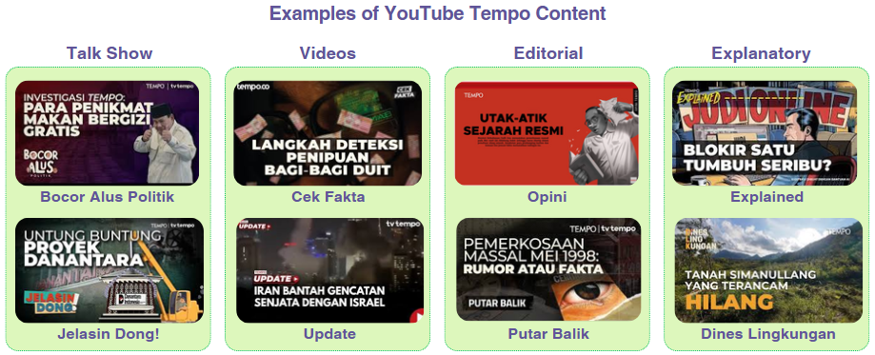

Table 5
Comparison of Alternatives Based on Criteria

No | Code | Alternative | Scale |  |  |  |  |  |  |  |  |  |  |  |  |  |  |  |  | Alternative
No | Code | Alternative | 9 | 8 | 7 | 6 | 5 | 4 | 3 | 2 | 1 | 2 | 3 | 4 | 5 | 6 | 7 | 8 | 9 | Alternative
 | D | Alt Vs  Quantitative |  |  |  |  |  |  |  |  |  |  |  |  |  |  |  |  |  | Alt Vs  Quantitative
1 | D1 | Talk show |  |  |  |  |  |  |  |  |  |  |  |  |  |  |  |  |  | Videos
2 | D2 | Talk show |  |  |  |  |  |  |  |  |  |  |  |  |  |  |  |  |  | Editorial
3 | D3 | Talk show |  |  |  |  |  |  |  |  |  |  |  |  |  |  |  |  |  | Explanatory
4 | D4 | Videos |  |  |  |  |  |  |  |  |  |  |  |  |  |  |  |  |  | Editorial
5 | D5 | Videos |  |  |  |  |  |  |  |  |  |  |  |  |  |  |  |  |  | Explanatory
6 | D6 | Editorial |  |  |  |  |  |  |  |  |  |  |  |  |  |  |  |  |  | Explanatory
 | E | Alt Vs  Qualitative |  |  |  |  |  |  |  |  |  |  |  |  |  |  |  |  |  | Alt Vs  Qualitative
1 | E1 | Talk show |  |  |  |  |  |  |  |  |  |  |  |  |  |  |  |  |  | Videos
2 | E2 | Talk show |  |  |  |  |  |  |  |  |  |  |  |  |  |  |  |  |  | Editorial
3 | E3 | Talk show |  |  |  |  |  |  |  |  |  |  |  |  |  |  |  |  |  | Explanatory
4 | E4 | Videos |  |  |  |  |  |  |  |  |  |  |  |  |  |  |  |  |  | Editorial
5 | E5 | Videos |  |  |  |  |  |  |  |  |  |  |  |  |  |  |  |  |  | Explanatory
6 | E6 | Editorial |  |  |  |  |  |  |  |  |  |  |  |  |  |  |  |  |  | Explanatory
 | F | Alt Vs  Production |  |  |  |  |  |  |  |  |  |  |  |  |  |  |  |  |  | Alt Vs  Production
1 | F1 | Talk show |  |  |  |  |  |  |  |  |  |  |  |  |  |  |  |  |  | Videos
2 | F2 | Talk show |  |  |  |  |  |  |  |  |  |  |  |  |  |  |  |  |  | Editorial
3 | F3 | Talk show |  |  |  |  |  |  |  |  |  |  |  |  |  |  |  |  |  | Explanatory
4 | F4 | Videos |  |  |  |  |  |  |  |  |  |  |  |  |  |  |  |  |  | Editorial
5 | F5 | Videos |  |  |  |  |  |  |  |  |  |  |  |  |  |  |  |  |  | Explanatory
6 | F6 | Editorial |  |  |  |  |  |  |  |  |  |  |  |  |  |  |  |  |  | Explanatory
 | G | Alt Vs  SEO Score |  |  |  |  |  |  |  |  |  |  |  |  |  |  |  |  |  | Alt Vs  SEO Score
1 | G1 | Talk show |  |  |  |  |  |  |  |  |  |  |  |  |  |  |  |  |  | Videos
2 | G2 | Talk show |  |  |  |  |  |  |  |  |  |  |  |  |  |  |  |  |  | Editorial
3 | G3 | Talk show |  |  |  |  |  |  |  |  |  |  |  |  |  |  |  |  |  | Explanatory
4 | G4 | Videos |  |  |  |  |  |  |  |  |  |  |  |  |  |  |  |  |  | Editorial
5 | G5 | Videos |  |  |  |  |  |  |  |  |  |  |  |  |  |  |  |  |  | Explanatory
6 | G6 | Editorial |  |  |  |  |  |  |  |  |  |  |  |  |  |  |  |  |  | Explanatory

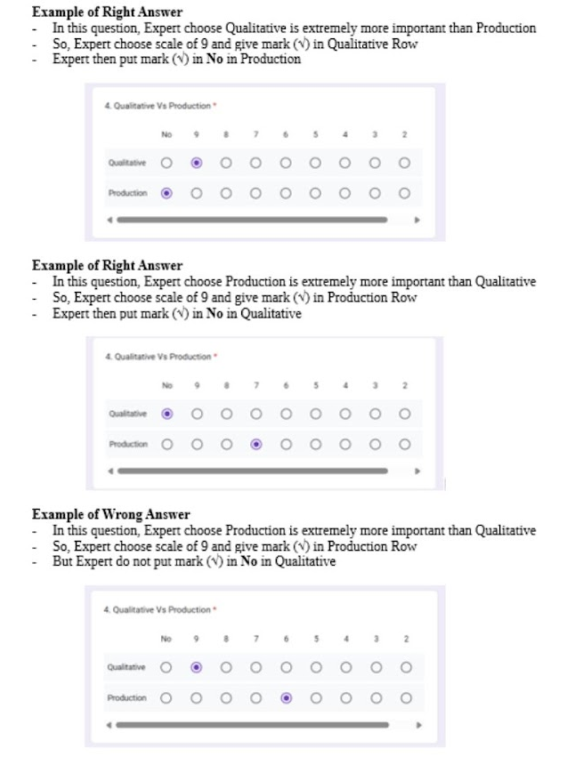

Table
Criteria and Sub-Criteria
Criteria | Sub-Criteria
Quantitative | Subscriber, CTR, Conversion Rate, Views
Qualitative | User Rating, Interaction Rate
Production | Cost, Duration
SEO Score | Title Word Count, Tags

Table
Examples of TEMPO YouTube Content
Alternative | TEMPO YouTube Content
Talk show | - Is a program featuring conversation, often hosted by a single/multi-persons who interview guests on various topics, including social, political, economic and business issues.  - Example: Bocor Alus Politik, Jelasin Dong!, Cakap-cakap
Videos | - Is a short video contains news from the multi-variety field. Not focused on explanation or editorializing.  - Example:Tempo Update, Breaking News, Cek Fakta, Live, Shorts
Editorial | - Is a content expressing opinions or editorial stance commentary on issues. Focuses on deep analysis and critique.  - Example:Opini, Putar Balik
Explanatory | - Is a video designed to explain complex issues, often using storytelling, graphics and many points of view are highlighted.  - Example: Explained (weekly), Explainer (daily), Dines Lingkungan (DLK)

Figure 1 Screenshot of Questionnaire in Google Form

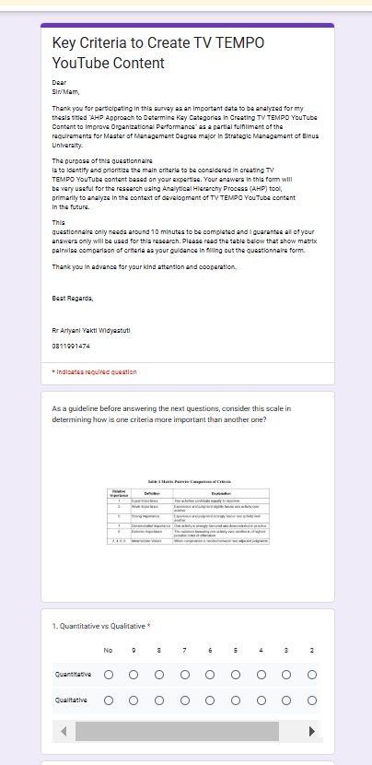

BIOGRAPHY

