Diagnostic Accuracy of Oral Gargle Samples as Non-Invasive Biomarkers for the Detection of Head and Neck Cancer: A Systematic Review and Meta-Analysis
Arbi Wijaya^{1,2}, Tsuyoshi Sugiura¹
1 Department of Oral Oncology and Surgical Sciences, Graduate School of Dentistry, Tohoku University, 980-0872, Sendai, Miyagi, Japan
2 Department of Oral and Maxillofacial Surgery, Faculty of Dentistry, Universitas Indonesia, 10430, Central Jakarta, Jakarta, Indonesia

Corresponding Author :

ABSTRACT
Background:
Head and Neck Squamous Cell Carcinoma (HNSCC) are often diagnosed at advanced stages, leading to poor prognosis. Conventional biopsy remains the diagnostic gold standard but is invasive and unsuitable for population-level screening. This systematic review and meta-analysis aimed to evaluate the diagnostic performance of oral gargle–derived molecular biomarkers as a non-invasive alternative for early cancer detection. Methods: A comprehensive literature search was conducted in PubMed, Medline, Scopus, CINAHL, and MedLink databases for studies published between January 2015 and October 2025. Eligible studies assessed the diagnostic accuracy of gargle-derived biomarkers including HPV DNA, HPV16 methylation, and host-gene methylation markers against histopathologic or molecular reference standards. Pooled sensitivity, specificity, and diagnostic odds ratios were calculated using a random-effects model, and summary receiver operating characteristic (SROC) curves were generated to evaluate overall accuracy. Study quality was assessed using the QUADAS-2 tool. Results: Fourteen studies encompassing 1,784 participants were included. The pooled sensitivity and specificity were 0.74 (95% CI, 0.66–0.80) and 0.92 (95% CI, 0.86–0.95), respectively, with an area under the SROC curve (AUC) of 0.89, indicating robust diagnostic performance. DNA methylation and HPV-based assays demonstrated the highest accuracy. Subgroup analysis showed comparable diagnostic values between HNSCC and OPSCC cohorts. Conclusion: Oral gargle–derived molecular biomarkers exhibit strong diagnostic accuracy and represent a promising, patient-friendly liquid biopsy approach for early detection of HNSCC and OPSCC. Standardization of biomarker panels and multicenter validation are warranted to advance clinical implementation in population-based screening and post-treatment surveillance.
Keywords: Head and neck squamous cell carcinoma,HNSCC, OPSCC, oral gargle, oral rinse, DNA methylation, HPV, sensitivity, specificity..

INTRODUCTION
Head and neck squamous cell carcinoma (HNSCC) remains a major global health concern. In 2020, it was the seventh most common cancer worldwide, accounting for approximately 890,000 new cases and 450,000 de$aths each year.¹ Despite ongoing advances in treatment, the overall prognosis for HNSCC has improved only modestly over the past decades. One of the main reasons is that most cases are diagnosed at a late stage, when curative options are limited. In the early stages (T1–T2), the disease often progresses silently, producing no noticeable symptoms. As a result, over 60% of patients are diagnosed at advanced stages (T3–T4), when the five-year survival rate drops to around 36%.^{2–4} This emphasizes the urgent need for affordable, rapid, and minimally invasive diagnostic tools that can detect malignancy earlier and improve clinical outcomes.
Traditionally, the definitive diagnosis of oral and oropharyngeal malignancies relies on a surgical biopsy, which provides tissue for histopathological examination to confirm the presence of malignant cells. This combination remains the gold standard in clinical practice because of its high diagnostic accuracy and ability to reveal detailed cellular morphology. However, the procedure is invasive and often associated with pain, infection risk, and potential cosmetic or functional complications, making it impractical for routine or repeated screening.⁵ Although histopathology provides superior diagnostic precision, it requires additional processing and interpretation, delaying results by several days and postponing clinical decision-making.⁶ Collectively, these challenges underscore the urgent need for alternative diagnostic approaches that can deliver reliable, rapid, and minimally invasive assessments while reducing the burden on both patients and clinicians.
In recent years, oral fluids including saliva and gargle samples have attracted growing interest as a noninvasive diagnostic medium. These fluids contain a rich array of biological molecules, such as hormones, cytokines, antibodies, and growth factors, which can mirror both local and systemic disease states.^{7–10} Moreover, oral fluids carry cells, proteins, and genetic material (DNA, RNA, and microRNA) that reflect molecular changes within tumor or pathogen-infected tissues.⁷ Because of these properties, oral fluids have emerged as a promising source of biomarkers for early cancer detection. Among various oral fluid-based techniques, gargle-derived biomarkers stand out as a particularly practical and patient-friendly option. The gargling process collects exfoliated tumor cells and tumor-derived nucleic acids from the oral cavity and oropharynx, making it possible to detect molecular signatures of malignancy with minimal discomfort and at low cost.
Therefore, this study aims to provide a clearer understanding of the diagnostic value of gargle-derived biomarkers and to explore their potential use as a noninvasive and accessible tool for the early detection of head and neck cancer.

METHODS
Search Strategy
A systematic literature search was conducted in PubMed, Medline, Scopus, CINAHL, and MedLink databases to identify studies evaluating the diagnostic accuracy of gargle-derived biomarkers for the early detection of head and neck cancer. The search strategy combined Medical Subject Headings (MeSH) and free-text terms using the following key words:
(head AND neck AND cancer) AND (gargle OR oral rinse OR mouthwash) AND (biomarker OR marker* OR molecular marker* OR RNA OR miRNA OR DNA OR protein*) AND (diagnostic accuracy OR sensitivity OR specificity OR ROC OR “receiver operating characteristic” OR predictive value OR AUC OR “area under curve”).
The search covered publications from January 2015 to October 2025. In addition, the reference lists of relevant articles and reviews were manually screened to identify additional eligible studies not captured by the initial search. The methods and reporting of this systematic review followed the Preferred Reporting Items for Systematic Reviews and Meta-Analyses (PRISMA) guidelines. The review protocol was prospectively registered in the PROSPERO database (Registration No..)
Inclusion & Exclusion Criteria
Studies were selected according to the PICOS (Population, Intervention, Comparison, Outcome, and Study Design) framework to ensure methodological consistency and relevance to the research objective. Eligible studies included those involving individuals at risk for or suspected of having early-stage head and neck cancer, in which gargle-derived biomarkers such as methylated DNA, HPV DNA/RNA, proteins, cytokines, or metabolites were analyzed from oral or oropharyngeal rinse samples. The diagnostic performance of these biomarkers had to be evaluated against a reference standard, typically histopathologic confirmation through surgical or biopsy specimens, or other conventional diagnostic assessments. Studies were required to report at least one diagnostic accuracy parameter, including sensitivity, specificity, positive predictive value (PPV), negative predictive value (NPV), or the area under the receiver operating characteristic curve (AUC). Eligible designs encompassed diagnostic accuracy studies, as well as prospective or retrospective cohort and case-control studies providing sufficient data for quantitative synthesis. Studies were excluded if they lacked complete diagnostic information, did not involve human subjects, or failed to analyze biomarkers derived from gargle or oral rinse samples. Non-original publications such as reviews, conference abstracts, editorials, or patents were also excluded, as were duplicate, overlapping, or retracted studies.
Study Selection
Two reviewers (A.W. and F.N.) independently conducted the literature search, study selection, data extraction, and quality assessment. Any discrepancies or uncertainties regarding study eligibility were resolved through discussion with a third reviewer (J.T) to reach consensus. From each eligible study, the following information was extracted: first author’s name, year of publication, country, study design, sample size, type of gargle sample (oral gargle or oral rinse), biomarker type, detection method, reference standard, target cancer type, and diagnostic performance indicators, including sensitivity, specificity, positive predictive value (PPV), negative predictive value (NPV), and area under the receiver operating characteristic curve (AUC). When true positive (TP), false positive (FP), true negative (TN), or false negative (FN) values were not explicitly reported, they were calculated from available diagnostic parameters such as sensitivity and specificity.
Quality Assesment
The methodological quality assesment each included study were evaluated using the Quality Assessment of Diagnostic Accuracy Studies-2 (QUADAS-2) tool, in accordance with Cochrane recommendations. This tool assesses four domains: patient selection, index test, reference standard, and flow and timing. Two reviewers (A.W & F.N) independently performed the assessments, and any disagreements were resolved through discussion or consultation with a third reviewer. Each domain was rated as having low, high, or unclear risk of bias, and applicability concerns were also recorded. The results of the quality assessment were visualized using the robvis (Risk-of-Bias Visualization) web tool (McGuinness & Higgins, BMJ, 2021), which generated traffic-light and summary plots for clearer presentation of bias distribution across studies.¹¹

Statistical Analysis
All statistical analyses were performed using Review Manager (RevMan) version 5.4 (The Cochrane Collaboration, Copenhagen, Denmark, 2020). Pooled sensitivity, specificity, and summary receiver operating characteristic (SROC) curves were calculated using a random-effects model.

RESULTS
Study Selection
The detailed process of literature identification and selection is summarized in Figure 1. A total of 955 records were initially retrieved from five databases, including PubMed (n = 63), MedLink (n = 142), Scopus (n = 707), CINAHL (n = 6), and MEDLINE (n = 37). After removing 222 duplicate records, 733 articles remained for title and abstract screening. Following this step, 657 studies were excluded for irrelevance to the research objectives. The full texts of 76 articles were then assessed for eligibility. Among these, 62 reports were excluded for the following reasons: not relevant to the research question or objectives (n = 35), insufficient or incomplete data for extraction or analysis (n = 6), inappropriate study design such as review articles, case reports, or commentaries (n = 13), studies outdated or superseded by a more recent publication from the same dataset (n = 7), and no fulltext available (n=1). Ultimately, 14 studies met the inclusion criteria and were included in the final systematic review and meta-analysis.

]

Identification of studies via databases and registers

Records identified from*:
Pubmed (n = 63)
Medlink (n = 142)
Scopus (n = 707)
CINAHL (n = 6)
MEDLINE (n = 37)

Total (n = 955 )
Records removed before screening:
Duplicate records removed (n = 222)

Identification

Screening

Records screened (title & abstract)
(n = 733)
Records excluded**
(n = 657)
Reports excluded:
- Not relevant to the research question or objectives (n = 35 )
- Insufficient or incomplete data for extraction or analysis (n = 6 )
- Inappropriate study design (e.g., review article, case report, commentary) (n = 13)
- Outdated or superseded by a more recent study from the same dataset (n = 7)
- No fulltext available (n=1)
Total (n = 62)

Reports assessed for eligibility
(n = 76 )

Studies included in review
(n = 14)
Reports of included studies
(n = 14)
Included

Figure 1. PRISMA (Preferred Reporting Items for Systematic Reviews and Meta-analyses)
flow diagram of the study selection.

Characteristic of Included Studies
A total of 14 studies published between 2015 and 2025 were included in this meta-analysis, involving 1,784 participants across diverse populations in the United States, Germany, Japan, and other regions. Study designs included cross-sectional (n=2), prospective (n=7), and case–control (n=5) frameworks. All studies utilized oral gargle or mouth rinse specimens as a non-invasive diagnostic medium, with volumes ranging from 15 to 20 mL and gargling durations of 15–60 seconds. The majority of studies investigated oropharyngeal squamous cell carcinoma (OPSCC) or head and neck squamous cell carcinoma (HNSCC). The biomarkers analyzed encompassed a wide molecular spectrum, including human papillomavirus (HPV) DNA detection, HPV16 methylation (L1, L2, E2 regions), host gene methylation markers (EPB41L3, CDH13, BRCA2, MLH1), and emerging genome-wide methylation panels. Detection methods varied, involving reverse hybridization assays (InnoLiPA, SPF10-LiPA25), PCR-based pyrosequencing, quantitative real-time PCR, and next-generation sequencing (NGS). Across studies, the reference standard was consistent, primarily based on histopathological confirmation combined with tumor p16 immunohistochemistry and/or HPV DNA or RNA positivity, in accordance with CAP/ASCO and AJCC 8th edition criteria. Reported diagnostic performances varied, with sensitivity ranging from 25% to 100%, specificity from 50% to 100%, and area under the curve (AUC) values from 0.78-0.94, as summarized in Table 1 and Table 2.

Table 1. Characteristic of Included Studies
Study ID | Country | Sudy Design | Sample Size | Target  Cancer Type | Type of  Sample | Biomarker  type | Detection  Methods | Reference  Standard
Langevin et al. (2025)^{12,13} | United States | Case-control | 226  (154 cases;  72 controls) | OPSCC | Oral rinse (30 mL mouthwash; 30 s) | CpG island DNA methylation profile (22-CGI panel) | Infinium HumanMethylation450 BeadArray (Illumina) | Histopathology (biopsy-confirmed diagnosis)
Chai et al.  (2016)¹³ | Australia | Prospective | 82 cases | HNSCC | Oral rinse (10 mL saline; 1 min) | HPV-16 DNA;  HPV-16 mRNA | qPCR | Tumor p16INK4a immunohistochemistry
Imai et al.  (2016)¹⁴ | Japan | Cross-sectional | 15 cases | OPSCC | Oral gargle (15 mL water; 30 s) | HPV DNA | Real-time PCR (cobas 4800 HPV) | Tumor p16 IHC and HPV-DNA ISH
Rosenthal et al.  (2017)¹⁵ | United States | Prospective | 268  (187 cases;81 controls) | OPSCC/OSCC | Oral rinse (10 mL saline; 30 s) | HPV 16; HPV 18 | Cobas HPV Test (RT- PCR) | Tumor p16 immunohistochemistry
Yoshida et .al  (2017)¹⁶ | Japan | Prospective | 19 cases | OPSCC | Oral rinse (20mL saline; 20 s) | HPV DNA | Auto-nested GP5+/GP6+ PCR | Tumor p16 immunohistochemistry
Martin-Gomez et al.  (2019)¹⁷ | United States | Cross-sectional | 171 Cases | OPSCC | Oral gargle (15mL mouthwash; 30 s) | Any oncogenic HPV  HPV-16 | RHA Kit HPV SP10-LiPA25 | Histopathology (biopsy-confirmed diagnosis); HPV genotyping, p16 IHC
Giuliano et al.  (2020)¹⁸ | United States | Case-control | 202  (101 cases; 101 controls) | OPSCC | Oral gargle (15mL mouthwash; 15 s) | HPV16 gene methylation (L1/L2/E2); EPB41L3 methylation | PCR-based pyrosequencing, HPV genotyping | Tumor p16 IHC, HPV DNA and/or RNA detection
Tanaka et al.  (2021)¹⁹ | Japan | Prospective | 68 Cases | OPSCC | Oral gargle (10 mL PBS; 30 s) | HPV DNA;  HPV mRNA;  ctHPV-16 DNA | GENOSEARCH HPV31 PCR, Aptima mRNA assay, ddPCR | Tumor p16 IHC & HPV DNA/RNA
Dickey et al.  (2022)²⁰ | United States | Case-control | 368  (228 cases:early stage 92 late stage 136; 142 controls) | OPSCC | Oral gargle (Mouthwash; 30 s) | HPV16/EPB41L3 | Pyrosequencing after bisulfite conversion | Histopathology (biopsy-confirmed diagnosis), p16 IHC, HPV DNA/RNA
Loermann et al.  (2022)²¹ | Germany | Prospective | 88 cases | OPSCC  HNSCC | Oral rinse (20ml serile-filtrated tap water; 1 min) | HPV-16;  HPV-DNA | InnoLiPA genotyping assay (reverse hybridization, PCR-based) | Tumor p16 IHC, HPV DNA, and/or RNA detection
Mori et al.  (2022)²² | Japan | Case-control | 56 cases  (40 training set; 16 test set) | OPMD  /OSCC | Oral gargle (20 mL purified water; 1 min) | DNA methylation of TP73, CASP8, RARB, KLLN, GSTP1, CHFR | MS-MLPA | Histopathology (biopsy-confirmed diagnosis)
Dickey et al.  (2024)²³ | United States | Case-control | 197  (89 cases; 108 controls) | OPSCC | Oral gargle (Mouthwash; 30 s) | 14-marker DNA methylation panel (CpG sites; includes EPB41L3, HPV16) | Illumina Infinium MethylationEPIC (genome-wide), pyrosequencing, PCR | Histopathology (biopsy-confirmed diagnosis), p16 IHC, HPV DNA/RNA from tumor
Galati et al.  (2025)²⁴ | Italy | Prospective | 141 cases | HNSCC | Oral gargle (15 mL saline; 15 s) | HPV DNA;  HPV-16 DNA | Multiplex PCR & Luminex bead assay | Tumor p16 IHC and/or tissue HPV testing
Noma et al.  (2025)²⁵ | Japan | Prospective | 60 cases  (40 training set;20 test set) | OSCC | Oral rinse (20 mL water; 30 s) | DNA methylation (BRCA2, CDH13) | qPCR melting curve analysis (RTAV) | Histopathology (biopsy-confirmed diagnosis)
HNSCC Head and Neck Squamous Cell Carcinoma, OPSCC Oropharyngeal Squamous Cell Carcinoma , OSCC Oral Squamous Cell Carcinoma, OPMD Oral Potentially Malignant Disorder, HPV Human Papillomavirus, DNA Deoxyribonucleic Acid , mRNA Messenger Ribonucleic Acid, CpG Cytosine–Phosphate–Guanine dinucleotide, CGI CpG Island, EPB41L3 Erythrocyte Membrane Protein Band 4.1-Like 3, ctHPV Circulating Tumor Human Papillomavirus DNA, TP73 Tumor Protein 73, CASP8 Caspase 8, RARB Retinoic Acid Receptor Beta, KLLN Killin, p53-regulated DNA replication inhibitor, GSTP1 Glutathione S-Transferase Pi 1, CHFR Checkpoint with Forkhead and Ring Finger Domains, qPCR Quantitative Polymerase Chain Reaction, ddPCR Droplet Digital Polymerase Chain Reaction, RHA Kit HPV SP10-LiPA25 Reverse Hybridization Assay Kit for HPV Genotyping (Line Probe Assay, version 25), MS-MLPA Methylation-specific multiplex ligation-dependent probe amplification, IHC Immunohistochemistry, ISH In Situ Hybridization.

Table 2. Summary of diagnostic performance metrics of the included studies
Author | Biomarker  type | TP | FP | FN | TN | Sensi-tivity (%) | Speci-  Ficity (%) | PPV  (%) | NPV  (%) | LR+ | LR- | AUC
Langevin et al. (2025) | CpG island DNA methylation profile (22-CGI panel) | 100 | 3 | 54 | 69 | 64.7 | 96 | 97 | 0.56 | 15.58 | 0.36 | 0.92
Chai et al.  (2016) | HPV-16 DNA | 22 | 0 | 18 | 40 | 93 | 100 | 100 | 93 | - | 0.07 | -
Chai et al.  (2016) | HPV-16 mRNA | 39 | 0 | 3 | 40 | 55 | 100 | 100 | 69 | - | 0.45 | -
Imai et al.  (2016) | HPV DNA | 3 | 0 | 2 | 10 | 60 | 100 | 100 | 83 | - | 0.4 | -
Rosenthal et al.  (2017) | HPV 16 & HPV 18 | 34 | 6 | 9 | 57 | 79.1 | 90.5 | 85 | 86.4 | 8.3 | 0.23 | -
Yoshida et al.  (2017) | HPV DNA | 9 | 0 | 3 | 7 | 75 | 100 | 100 | 70 | - | 0.25 | -
Martin-Gomez et al.  (2019) | Any oncogenic HPV | 119 | 7 | 38 | 7 | 75.8 | 50 | 94.4 | 15.6 | 1.51 | 0.48 | -
Martin-Gomez et al.  (2019) | HPV-16 DNA | 104 | 6 | 39 | 22 | 72.7 | 78.6 | 94.5 | 36.1 | 0.39 | 0.34 | -
Giuliano et al.  (2020) | HPV16 gene methylation (L1/L2/E2), EPB41L3 methylation | 71 | 9 | 30 | 92 | 70.3 | 90.9 | 88.7 | 75.4 | 7.88 | 0.32 | 0.885
Tanaka et al.  (2021) | HPV DNA | 32 | 0 | 7 | 29 | 82 | 100 | 100 | 80.5 | N/A | 0.17 | -
Tanaka et al.  (2021) | HPV mRNA | 33 | 1 | 6 | 17 | 85 | 94 | 97 | 73.9 | 15.2 | 0.16 | -
Tanaka et al.  (2021) | ctHPV-16 DNA | 39 | 1 | 3 | 31 | 93 | 97 | 97.5 | 91.1 | 29.7 | 0.07 | -
Dickey et al.  (2022) | HPV16/EPB41L3  (early stage) | 106 | 34 | 30 | 108 | 76 | 65 | 58.3 | 80.7 | 2.16 | 0.36 | 0.82
Dickey et al.  (2022) | HPV16/EPB41L3  (late stage) | 70 | 50 | 22 | 92 | 78 | 76 | 75.7 | 78.2 | 3.25 | 0.29 | -
Loermann et al.  (2022) | HNSCC HPV-16 | 5 | 2 | 13 | 39 | 28 | 95 | 71.4 | 75 | 5.69 | 0.75 | -
Loermann et al.  (2022) | HNSCC HPV DNA | 9 | 6 | 9 | 35 | 50 | 85 | 60 | 79 | 3.41 | 0.58 | -
Loermann et al.  (2022) | OPSCC HPV-16 | 3 | 1 | 9 | 18 | 25 | 95 | 75 | 66.6 | 4.75 | 0.79 | -
Loermann et al.  (2022) | OPSCC HPV DNA | 7 | 3 | 5 | 16 | 58 | 84 | 70 | 76.1 | 3.69 | 0.49 | -
Mori et al.  (2022) | DNA methylation (6 tumor suppressor genes: TP73, CASP8, RARB, KLLN, GSTP1, CHFR)  (Training set) | 7 | 4 | 2 | 27 | 77.8 | 87 | 63.6 | 93.1 | 6.02 | 0.25 | 0.885
Mori et al.  (2022) | DNA methylation (6 tumor suppressor genes: TP73, CASP8, RARB, KLLN, GSTP1, CHFR)  (Test set) | 4 | 2 | 2 | 8 | 66.7 | 80 | 66.7 | 80 | 3.33 | 0.41 | 0. 833
Dickey et al.  (2024) | 14-marker DNA methylation panel (CpG sites; includes EPB41L3, HPV16 methylation) | 62 | 1 | 27 | 107 | 70.1 | 99.1 | 98.4 | 79.8 | 75.2 | 0.3 | 0.964
Galati et al.  (2025) | HPV DNA (esp. HPV16) | 14 | 1 | 0 | 6 | 100 | 85.9 | 93.3 | 100 | 7 | 0 | -
Noma et al.  (2025) | DNA methylation (BRCA2, CDH13)  (Training set) | 16 | 6 | 4 | 14 | 80 | 70 | 72.2 | 77.8 | 2.67 | 0.28 | 0.78
Noma et al.  (2025) | DNA methylation (BRCA2, CDH13)  (Test set) | 8 | 2 | 2 | 8 | 80 | 80 | 80 | 80 | 4 | 0.25 | 0. 830
TP True positive, FP False positive, FN False negative, TN True negative, LR+ Positive Likelihood Ratio, LR- Negative Likelihood Ratio, AUC Area Under Curve

Data Analysis
Pooled sensitivity, specificity, and diagnostic odds ratios were calculated using a random-effects model. Forest plots were constructed to visually summarize individual study estimates and pooled effects, providing an overview of variation across studies. In addition, summary receiver operating characteristic (SROC) curves were generated to assess overall test performance.

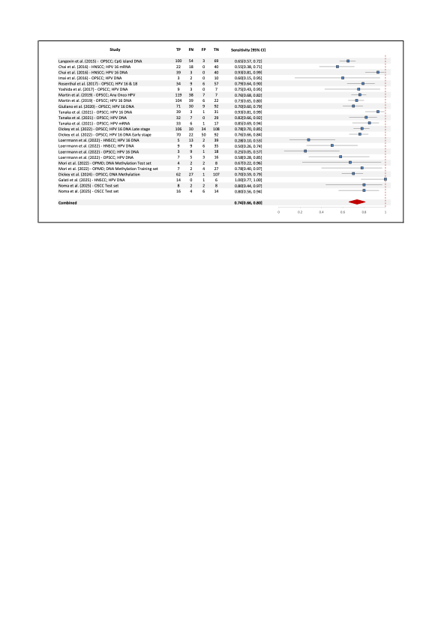

Figure 2. Forest plot showing the pooled sensitivity of oral gargle–derived molecular biomarkers for HNSCC and OPSCC detection. Squares indicate individual study estimates with 95% CIs; the diamond represents the pooled value.

High-performing assays were consistently observed in studies utilizing combined viral–host genomic markers (Fig. 2). For instance, Tanaka et al. (2021) achieved sensitivities between 0.82 and 0.93 using ctHPV16 DNA, HPV DNA, and mRNA assays, and Dickey et al. (2024) reported a sensitivity of 0.70 (95% CI 0.59–0.79) using a 14-gene methylation panel. Similarly, Giuliano et al. (2020) reported 0.70 (95% CI 0.60–0.79) with combined EPB41L3 and HPV16 gene methylation, while Langevin et al. (2015) observed 0.65 (95% CI 0.57–0.72) from CpG island methylation profiling. Despite interstudy variability, the majority of estimates clustered between 0.65 and 0.85, confirming moderate-to-high sensitivity across diverse molecular platforms. The pooled sensitivity derived from a random-effects model was 0.74 (95% CI 0.66–0.80), indicating that approximately three-quarters of true-positive cancer cases could be correctly identified through oral gargle–based molecular testing.

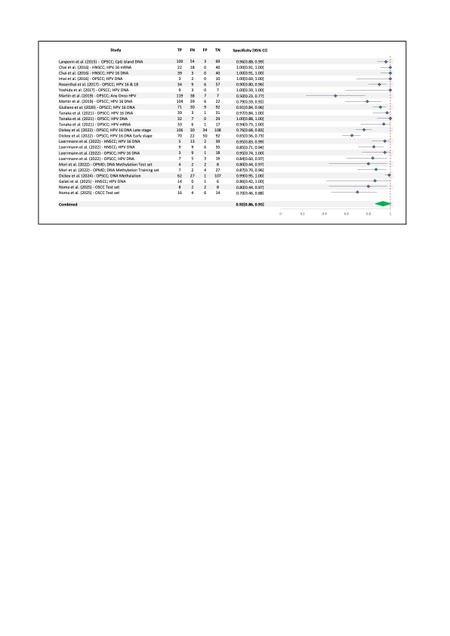

Figure 3. Forest plot showing the pooled specificity of oral gargle–derived molecular biomarkers for HNSCC and OPSCC detection. Diamonds indicate the pooled estimate; horizontal lines represent 95% confidence intervals.
Specificity was consistently high across the majority of studies (Fig. 3), ranging from 0.50 (95% CI 0.23–0.77) in Martin et al. (2019) to 1.00 (95% CI 0.91–1.00) in multiple HPV- and methylation-based assays such as those by Chai et al. (2016), Imai et al. (2016), and Tanaka et al. (2021) . Studies employing DNA methylation and HPV16 detection methods demonstrated particularly strong specificity, often exceeding 0.90. The pooled specificity calculated using a random-effects model was 0.92 (95% CI 0.86–0.95), confirming the consistently low false-positive rate of gargle-derived biomarkers for detecting head and neck malignancies.
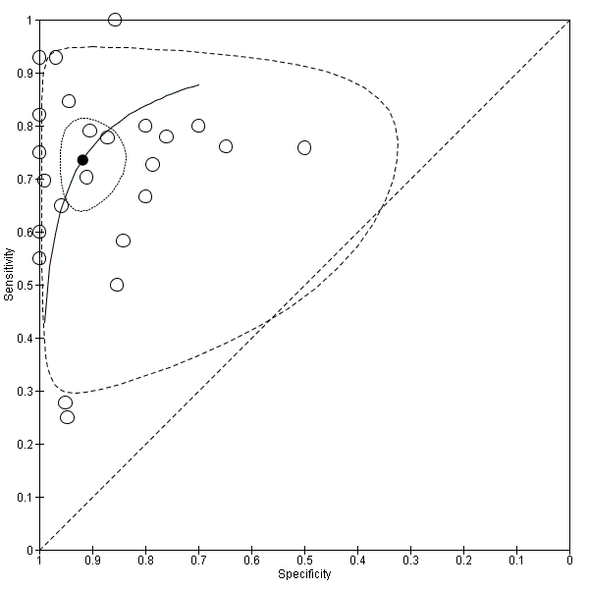
Figure 4. Summary receiver operating characteristic (SROC) curve for oral gargle–derived molecular biomarkers in HNSCC and OPSCC detection. Each circle represents an individual study; the solid black line indicates the summary ROC curve, and the dashed line shows the 95% confidence region.

The SROC curve (Fig. 4) shows that most studies cluster toward the upper-left region, indicating overall good diagnostic performance. The pooled summary point (black circle) suggests a sensitivity of about 0.75 and specificity of about 0.90, reflecting a well-balanced ability to detect true cases while minimizing false positives. The curve’s upward-left shape and an estimated AUC of around 0.89 further support that the test performs reliably in distinguishing diseased from non-diseased individuals. Although some variation exists among studies, the overall pattern demonstrates consistently strong accuracy across the included data.
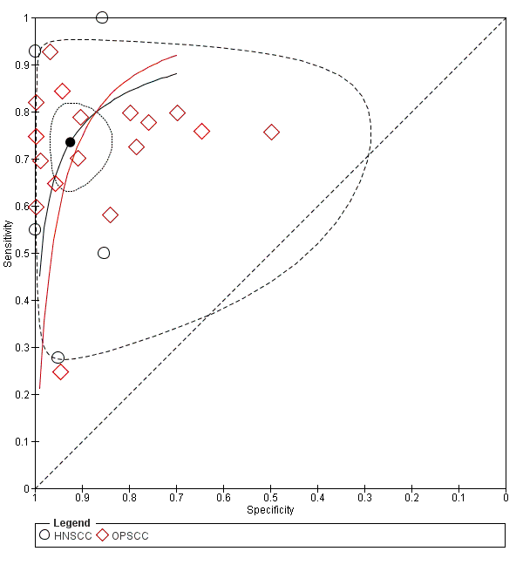
Figure 5. Summary receiver operating characteristic (SROC) curve comparing diagnostic accuracy between oral gargle–derived biomarkers for HNSCC (black circles) and OPSCC (red diamonds). Each point represents an individual study; the solid curves indicate the summary ROC for each subgroup, and the dashed lines represent the 95% confidence region.
When plot compares diagnostic performance between HNSCC (black circles) and OPSCC (red diamonds) studies, both subgroups cluster toward the upper-left region, indicating good overall accuracy (Fig. 5). The OPSCC subgroup shows a slightly higher curve, suggesting better sensitivity at comparable specificity levels. The pooled summary point (black circle) remains around sensitivity ≈ 0.75 and specificity ≈ 0.90, reflecting strong discriminative ability overall. The upward-left shape of both curves and an estimated AUC ≈ 0.89 indicate that the biomarker performs well in distinguishing cancer from non-cancer cases, with OPSCC showing marginally superior accuracy.

Quality Assesment
The methodological quality of all included studies was evaluated using the QUADAS-2 tool.²⁶ As summarized in Figure 6, most studies demonstrated a low risk of bias in the reference standard and flow & timing domains, reflecting consistent verification procedures and appropriate diagnostic reference methods. Conversely, some concerns were noted in the patient selection and index test domains, primarily due to non-consecutive sampling strategies and limited reporting of blinding during index-test interpretation. The overall risk of bias was considered acceptable, with no study rated as high risk in any domain. The distribution of risk levels across domains is illustrated in Figure Y, showing that more than half of the studies achieved low risk in three or more domains. Collectively, these findings indicate moderate-to-high methodological quality and support the reliability of the pooled diagnostic estimates

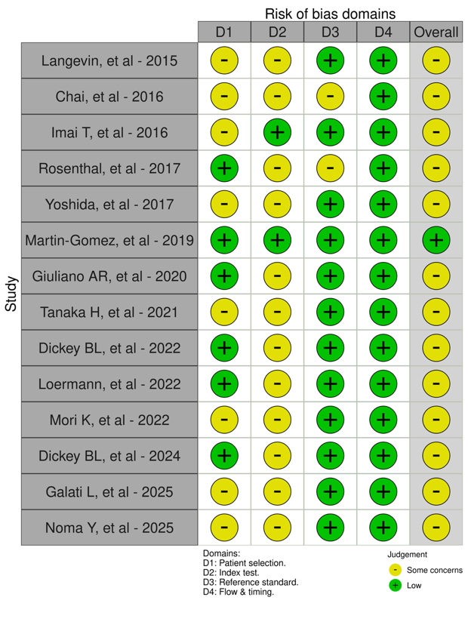

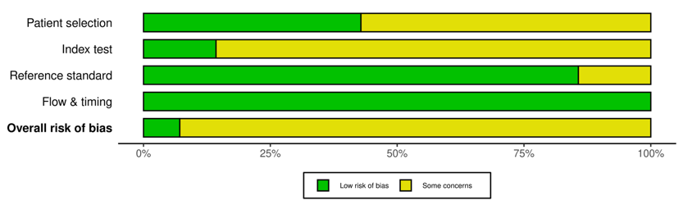

Figure 6. Risk of bias assessment for included studies using QUADAS-2 criteria. Each domain represents patient selection, index test, reference standard, and flow and timing. Green indicates a low risk of bias, and yellow indicates some concerns. Most studies showed an overall low to moderate risk of bias across domains.

DISCUSSION
Many cancer cases are diagnosed at an advanced stage, when curative treatment options are limited, largely due to the stagnation of conventional diagnostic techniques.[1] Given these diagnostic limitations, increasing attention has been directed toward noninvasive liquid biopsy approaches that can detect cancer-associated molecular alterations from easily accessible body fluids. Among these, oral gargle sampling has emerged as a particularly practical and patient-friendly alternative. This method allows the collection of exfoliated epithelial and tumor-derived materials from the oral cavity and oropharynx in a simple and noninvasive, making it suitable for both large-scale screening and longitudinal monitoring of HNSCC.²²
This meta-analysis synthetizing 14 eligible studies with 1,784 subjects, showed that biomarkers obtained from oral gargle and rinse samples achieved a combined sensitivity 0.74 (95% CI 0.66–0.80) and specificity of 0.92 (95% CI 0.86–0.95), with an AUC of 0.89. These findings are in line with previous meta-analyses utilizing other liquid biopsy media particularly saliva and plasma. For example, Liu et al. reported a combined sensitivity of saliva biomarkers in OSCC of 0.70 (95% CI: 0.63–0.77) and a specificity of 0.82 (95% CI: 0.72–0.90). Meanwhile, in blood plasma, the results were 0.79 (95% CI: 0.73–0.84) and 0.82 (95% CI: 0.77–0.86). These results indicate that the meta-analysis results of gargle samples are very comparable to those obtained from other media, such as saliva and blood plasma.²⁷
Moreover, most of the biomarkers analyzed in this study were HPV DNA, reflecting the established association between the incidence of HNSCC and OPSCC and human papillomavirus (HPV) infection in oral gargle samples, particularly HPV-16. Chai et al. reported that the sensitivity of the HPV-16 DNA test reached 92.9% in gargle samples collected from p16^{INK4a}-positive patients.¹³ This finding is consistent with a previous report by Koskinen et al., which showed a higher viral DNA load in OPSCC tumor samples compared to tumors from non-oropharyngeal sites.²⁸ However, these results are somewhat at odds with the study by Agrawal et al., which showed that only 30% of gargle samples from HPV-16-positive tumors contained detectable levels of HPV-16 DNA when using a PCR assay targeting the L1 region of the viral genome. In this meta-analysis, we also observed significant variation in sensitivity values, ranging from the highest Chai et al., with sensitivity 1.00 (95% CI 0.96–1.00) to the lowest Martin et al., with sensitivity 0.50 (95% CI 0.23–0.77).^{13,17} This variability may be due to differences in test design, genomic target regions, viral load, and sample collection efficiency. PCR tests targeting the L1 region also may underestimate positivity in integrated HPV genomes, while E6/E7-based tests provide higher sensitivity by detecting transcriptionally active infections. Additional factors such as primer specificity, tumor location, and pre-analytical handling also influence diagnostic results.^{29–31}
Furthermore, this study also included analyses investigating the DNA methylation profiles of tumor suppressor genes such as TP73, CASP8, RARB, KLLN, GSTP1, CHFR, EPB41L3, BRCA2, and CDH13, which are epigenetically regulated through promoter CpG island methylation detected in oral gargle derived DNA. Mori et al. reported that a six-gene methylation panel (TP73, CASP8, RARB, KLLN, GSTP1, and CHFR) in oral gargle samples could distinguish oral squamous cell carcinoma from OPMDs with good diagnostic performance with sensitivity 0.78 [95% CI 0.40–0.97] and specificity 0.87 [95% CI 0.70–0.96], supporting its potential for early detection.²² We included OPMD in the analysis because, although most head and neck squamous cell carcinomas (HNSCC) arise de novo, some cases are preceded by clinically detectable precursor lesions collectively defined as OPMD.³² In addition, building on the previous discussion regarding HPV, HPV infection has also been shown to modulate DNA methylation and contribute to malignant transformation, although its role in oral rather than oropharyngeal lesions remains less clearly understood. Further studies are needed to clarify the interaction between HPV infection, CpG island methylation, and the progression of OPMDs into squamous cell carcinoma in the oropharyngeal region.^{33,34}
Several limitations warrant consideration in this study. First, inter-study heterogeneity was moderate, driven by differences in biomarkers, assay platforms, and patient inclusion criteria. Second, most studies were conducted in tertiary centers, which may limit external validity for screening populations. Third, publication bias remains possible given the small number of studies and the tendency to report positive findings. Fourth, direct head-to-head comparisons between gargle and other biofluids such as plasma or saliva were scarce, precluding formal cross-matrix calibration. Lastly, although methylation and viral assays demonstrated consistent performance, large-scale prospective multicenter validations are still required to confirm diagnostic reproducibility and cost-effectiveness. Future research integrating machine learning–based risk algorithms with liquid biopsy biomarkers may further refine predictive precision and facilitate individualized screening frameworks.
CONCLUSION
Molecular biomarkers derived from oral gargles provide a minimally invasive and reliable method for the detection of HNSCC. The pooled diagnostic estimates suggest that the overall accuracy is robust and comparable to biomarkers derived from blood plasma and saliva. Gargle-based sampling offers practical advantages in terms of patient comfort, simplicity of collection, and suitability for repeated monitoring, underscoring its clinical potential as an adjunct or alternative to conventional invasive diagnostic procedures. However, the necessity of large-scale, multicenter validation studies to standardize protocols and verify diagnostic reproducibility is emphasized by the heterogeneity in assay methods, biomarker targets, and study design.
REFERENCES
1 Barsouk A, Aluru JS, Rawla P, Saginala K, Barsouk A. Epidemiology, Risk Factors, and Prevention of Head and Neck Squamous Cell Carcinoma. Medical sciences. 2023; 11. doi:10.3390/medsci11020042.
2 Sykes EA, Weisbrod N, Rival E, Haque A, Fu R, Eskander A. Methods, Detection Rates, and Survival Outcomes of Screening for Head and Neck Cancers A Systematic Review. In: JAMA Otolaryngology - Head and Neck Surgery. American Medical Association, 2023, pp 1047–1056.
3 Li Q, Tie Y, Alu A, Ma X, Shi H. Targeted therapy for head and neck cancer: signaling pathways and clinical studies. Signal Transduct Target Ther. 2023; 8. doi:10.1038/s41392-022-01297-0.
4 Johnson DE, Burtness B, Leemans CR, Lui VWY, Bauman JE, Grandis JR. Head and neck squamous cell carcinoma. Nat Rev Dis Primers. 2020; 6. doi:10.1038/s41572-020-00224-3.
5 Omar E. Current concepts and future of noninvasive procedures for diagnosing oral squamous cell carcinoma - a systematic review. Head Face Med. 2015; 11. doi:10.1186/s13005-015-0063-z.
6 Kossatz S, Pirovano G, Demétrio De Souza França P, Strome AL, Sunny SP, Zanoni DK et al. Validation of the use of a fluorescent PARP1 inhibitor for the detection of oral, oropharyngeal and oesophageal epithelial cancers. Nat Biomed Eng 2020; 4: 272–285.
7 Lima DP, Diniz DG, Moimaz SAS, Sumida DH, Okamoto AC. Saliva: reflection of the body. International Journal of Infectious Diseases. 2010; 14. doi:10.1016/j.ijid.2009.04.022.
8 Pfaffe T, Cooper-White J, Beyerlein P, Kostner K, Punyadeera C. Diagnostic potential of saliva: Current state and future applications. Clin Chem. 2011; 57: 675–687.
9 5. Intro SLR MA 2.CP. .
10 Zhang X, Kulasinghe A, Karim RS, Punyadeera C. Saliva diagnostics for oral diseases. In: Advances in Salivary Diagnostics. Springer Berlin Heidelberg, 2015, pp 131–156.
11 McGuinness LA, Higgins JPT. Risk-of-bias VISualization (robvis): An R package and Shiny web app for visualizing risk-of-bias assessments. In: Research Synthesis Methods. John Wiley and Sons Ltd, 2021, pp 55–61.
12 Langevin SM, Eliot M, Butler RA, Cheong A, Zhang X, McClean MD et al. CpG island methylation profile in noninvasive oral rinse samples is predictive of oral and pharyngeal carcinoma. Clin Epigenetics 2015; 7. doi:10.1186/s13148-015-0160-7.
13 Chai RC, Lim Y, Frazer IH, Wan Y, Perry C, Jones L et al. A pilot study to compare the detection of HPV-16 biomarkers in salivary oral rinses with tumour p16INK4a expression in head and neck squamous cell carcinoma patients. BMC Cancer 2016; 16. doi:10.1186/s12885-016-2217-1.
14 imai. .
15 Rosenthal M, Huang B, Katabi N, Migliacci J, Bryant R, Kaplan S et al. Detection of HPV related oropharyngeal cancer in oral rinse specimens. www.impactjournals.com/oncotarget.
16 Yoshida H, Murono S, Ueno T, Nakanishi Y, Tsuji A, Hatano M et al. Usefulness of human papillomavirus detection in oral rinse as a biomarker of oropharyngeal cancer. Acta Otolaryngol 2017; 137: 773–777.
17 Martin-Gomez L, Fulp WJ, Schell MJ, Sirak B, Abrahamsen M, Isaacs-Soriano KA et al. Oral gargle-tumor biopsy human papillomavirus (HPV) agreement and associated factors among oropharyngeal squamous cell carcinoma (OPSCC) cases. Oral Oncol 2019; 92: 85–91.
18 Giuliano AR, Nedjai B, Lorincz AT, Schell MJ, Rahman S, Banwait R et al. Methylation of HPV 16 and EPB41L3 in oral gargles: Associations with oropharyngeal cancer detection and tumor characteristics. Int J Cancer 2020; 146: 1018–1030.
19 Tanaka H, Suzuki M, Takemoto N, Fukusumi T, Eguchi H, Takai E et al. Performance of oral HPV DNA, oral HPV mRNA and circulating tumor HPV DNA in the detection of HPV-related oropharyngeal cancer and cancer of unknown primary. Int J Cancer 2022; 150: 174–186.
20 Dickey BL, Nedjai B, Preece MD, Schell MJ, Boulware D, Whiting J et al. Methylation of HPV16 and EPB41L3 in oral gargles and the detection of early and late oropharyngeal cancer. Cancer Med 2022; 11: 3735–3742.
21 Loermann G, Kolb M, Prascevic D, Siemert J, Wiegand S, Zebralla V et al. High-Risk Human Papillomavirus (HR-HPV) DNA Detection in Mouthwashes for Diagnosis of HPV-Driven Oropharynx Cancer and Its Curative Therapy—A Feasibility Study. J Clin Med 2022; 11. doi:10.3390/jcm11195509.
22 Mori K, Hamada T, Beppu M, Tsuchihashi H, Goto Y, Kume K et al. Detecting Early-Stage Oral Cancer from Clinically Diagnosed Oral Potentially Malignant Disorders by DNA Methylation Profile. Cancers (Basel) 2022; 14. doi:10.3390/cancers14112646.
23 Dickey BL, Putney RM, Schell MJ, Berglund AE, Amelio AL, Caudell JJ et al. Identification of a Biomarker Panel from Genome-Wide Methylation to Detect Early HPV-Associated Oropharyngeal Cancer. Cancer Prevention Research 2024; 17: 169–176.
24 Galati L, Tagliabue M, Gheit T, De Berardinis R, Maffini F, McKay-Chopin S et al. HPV Biomarkers in Oral and Blood-Derived Body Fluids in Head and Neck Cancer Patients. J Med Virol 2025; 97. doi:10.1002/jmv.70278.
25 Noma Y, Sawayama H, Yamashiro K, Nishi K, Yoshinaga H, Takaoka R et al. Melting curve analyses in the quantitative real-time polymerase chain reaction of methylated/non-methylated DNA toward the detection of oral cancer using gargle fluid. Heliyon 2025; 11. doi:10.1016/j.heliyon.2025.e42286.
26 Westwood M, Deeks JJ, Whiting PF, Weswood ME, Rutjes AW, Reitsma JB et al. QUADAS-2: A Revised Tool for the Quality Assessment of Diagnostic Accuracy Studies Evaluation of QUADAS, a tool for the quality assessment of diagnostic accuracy studies. Article in Annals of Internal Medicine 2011. doi:10.1059/0003-4819-155-8-201110180-00009.
27 Liu D, Xin Z, Guo S, Li S, Cheng J, Jiang H. Blood and Salivary MicroRNAs for Diagnosis of Oral Squamous Cell Carcinoma: A Systematic Review and Meta-Analysis. Journal of Oral and Maxillofacial Surgery. 2021; 79: 1082.e1-1082.e13.
28 Koskinen WJ, Chen RW, Leivo I, Mäkitie A, Bäck L, Kontio R et al. Prevalence and physical status of human papillomavirus in squamous cell carcinomas of the head and neck. Int J Cancer 2003; 107: 401–406.
29 Smeets SJ, Hesselink AT, Speel EJM, Haesevoets A, Snijders PJF, Pawlita M et al. A novel algorithm for reliable detection of human papillomavirus in paraffin embedded head and neck cancer specimen. Int J Cancer 2007; 121: 2465–2472.
30 Jakobsen KK, Carlander ALF, Bendtsen SK, Garset-Zamani M, Lynggaard CD, Grønhøj C et al. Diagnostic accuracy of hpv detection in patients with oropharyngeal squamous cell carcinomas: A systematic review and meta-analysis. Viruses. 2021; 13. doi:10.3390/v13091692.
31 Holzinger D, Wichmann G, Baboci L, Michel A, Höfler D, Wiesenfarth M et al. Sensitivity and specificity of antibodies against HPV16 E6 and other early proteins for the detection of HPV16-driven oropharyngeal squamous cell carcinoma. Int J Cancer 2017; 140: 2748–2757.
32 Vermorken JB, Langendijk JA, Leemans CR, Machiels J-P, Nicolai P, O’sullivan B. Critical Issues in Head and Neck Oncology Key Concepts from the Ninth THNO Meeting. .
33 Buenahora MR, Lafaurie GI, Perdomo SJ. Identification of HPV16-p16INK4a mediated methylation in oral potentially malignant disorder. Epigenetics 2021; 16: 1016–1030.
34 Ringström E, Peters E, Hasegawa M, Posner M, Liu M, Kelsey KT. Human Papillomavirus Type 16 and Squamous Cell Carcinoma of the Head and Neck 1. http://aacrjournals.org/clincancerres/article-pdf/8/10/3187/2081541/df1002003187.pdf.

